Mentored Fundraising Assignment 18 Homework Instructions
6-Month Mentored Nonprofit Fundraising Certificate Program
Center for Sustainable Development. https://nonprofit.csd-i.org/nonprofit-fundraising-training-certificate/

Assignment 18: What should your email look like? How long? What will lure subscribers to click through to an actionable landing page?
Email Newsletters. Romance your Subscribers

This week’s resources:
Class Home Page for Mentored Fundraising
Fundraising Assignment 18 Homework Instructions

Assignment Eighteen. Email Content and Layout
What should your email look like? How long? What will lure subscribers to click through to an actionable landing page?

I hate to keep harping on the "G" word, but what is your goal for your email newsletter? Do you want subscribers, donors, volunteers?

Unless they’re in the market for a new pair of shoes and want to hear about some tremendous online offers, most readers of nonprofit email newsletters will be interested in information and stories.

You can spend an extraordinary amount of time each week putting a newsletter together. A replicable template really speeds things up. So at the point when you’re happy with your newsletter layout—you can simply copy and paste in new content each week to change the text and photos.

Some of the really big, successful online marketers have the simplest newsletters. Short, plain copy, no graphics. They simply want to link you to their website landing page where you can see opportunities that you can purchase.

Some nonprofits have very short nonprofit email newsletters, but that have captivating photographs and short story lines that you can click on to find out more.

You will need to determine which formula is the best for you by testing. For example, one week you can send out a stripped down newsletter and see what your click-through rate is. The next week you can send out a more graphic newsletter and see what your click-through rate is. Each of the email service providers have tools for doing this testing.

But remember, the single biggest determinant in opening your email is your subject line—not the body of the email—because they can’t even see it unless they open it: just the subject line.

Mobile is also huge. Some studies have shown 60% of emails are opened up on mobile devices. So your email needs to be short and sweet and easily readable on a cell phone—or on a tablet.

But back to the goal. The goal is to get people to 1) open your email and then 2) click on a link that takes them to a landing page on your website. At that landing page they will be able to find educational information, calls to action to donate, subscribe, or volunteer, and they will also see other opportunities for engaging with your organization.

So my suggestion is to:
1. Write a newsletter subject line that is irresistible to your audience.
2. Compose a short email illuminating the subject line but not giving all of the information away—until they click through to your landing page.
3. Perfect your landing page.

A happy consequence for you if you use a very simple email newsletter is reduced time in putting it together. Invest your time in a good subject line and an awesome landing page. With a replicable newsletter template you can copy and paste a few key lines from your landing page into the newsletter—and get it sent off.

The Steps
1. Choose your style. Do you want a minimalist newsletter or highly graphic newsletter? The resources below can show you different examples.
2. Invest time in your subject line. You need people to open your email.
3. Invest time in your landing page. This is where people will decide to subscribe, donate, volunteer.
4. The email itself should simply lure people to your landing page.

Subject Line Examples
Just below are examples of nine great subject lines that I spotted in my inbox just now. I’ve also included screenshots of several of their newsletters themselves.

The first thing to notice is how short and simple the subjects lines are—and how they make you want to open the newsletter.

Secondly, look at how short and simple the emails are themselves. They get right to the point, they help you understand what you’re going to learn or be able to download, or participate in if you click on the link to their landing page.

Several of them are nicely formatted and have images. Your email service provider will have these graphic tools [and attractive newsletter templates] available to you.

Take a look at the New York Times email: with the exception of their standardized heading it’s pretty simple—both in content and in formatting.

Look at Brian Dean’s and Ramsey’s (Blog Tyrant) emails: they have a simple ‘just typed in’ look to them. But, if you click on the link their landing pages are beautifully done.

So, the pros seem to find that simple is better.

It only took me 15 minutes to go through a week’s worth of emails, identify some compelling subject lines, and take it closer look at the emails themselves; I think it would be good idea if you did the same thing! Create a collection of ideas. Just copy and paste into a Word document and save it so that you can find it. And when it comes time to do your next subject line for your next newsletter you’ll have some inspiration.

Here are the nine subject line examples:
1. WordStream:
[Live] 20 Minutes, Better PPC Results
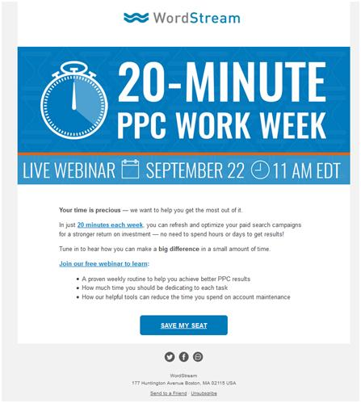

2. Chronicle of Philanthropy:
DIY fundraising: Learn how to motivate your supporters
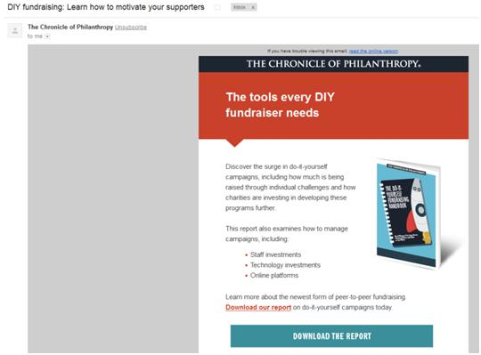
3. Blog Tyrant:
101 blogging tips for when you are totally stuck

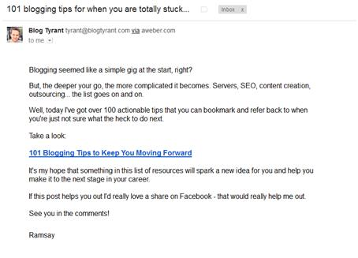

4. Charity Job:
Will you give us a second chance?

5. NYT Well: Oh Sugar, Sugar
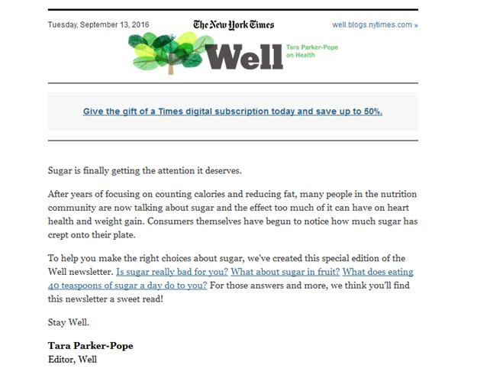

6. Seattle Tilth:
More Farmers = More Food — Support farmers — Donate today!

7. Kivi:
Tweet Like a Boss! [NEW WEBINAR NEXT WEEK]

8. Ecologic:
October 20: You’re Invited to Dinner!

9. Brian Dean:
New video: How to rank #1 in Google (step-by-step)
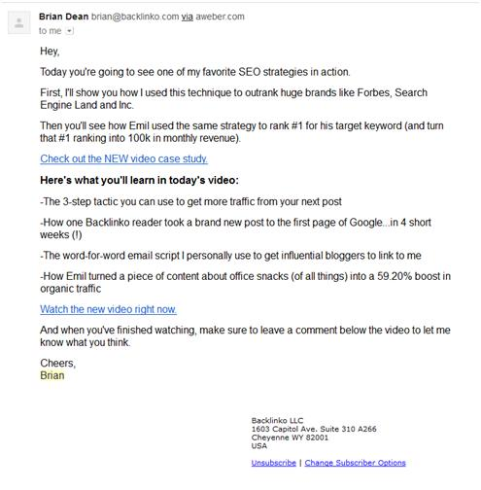
Newsletter Examples:
As per norm, I have included these additional resources.

Google search: What should your email newsletter look like?
https://www.google.com/search?source=hp&ei=yvUAXYH3BeyN_QbN6pL4Aw&q=What+should+your+email+newsletter+look+like%3F&oq=What+should+your+email+newsletter+look+like%3F&gs_l=psy-ab.12..33i22i29i30.1258.2984..3305...0.0..0.180.481.0j3......0....2j1..gws-wiz.....0.c-FuiUDphNk

17 Email Newsletter Examples We Love Getting in Our Inboxes
https://blog.hubspot.com/marketing/email-newsletter-examples-list

How to Create an Email Newsletter People Actually Read
https://blog.hubspot.com/marketing/guide-creating-email-newsletters-ht

6 E-Newsletter Best Practices for 2016
https://www.mailonthemark.com/6-e-newsletter-best-practices-for-2016/

5 Steps to an Email Newsletter Your Customers Will Love (and share!)
https://www.ducttapemarketing.com/blog/email-newsletters/

The homework to turn in:
1. Write a simple, text only newsletter (like Brian and Ramsey did in their examples above) based upon the initial work you did in Assignment 16 (topic, audience, subject line).

2. Let readers know what to look forward to on your landing page—but don't give them all the information—just give them a link to the landing page for them to be able to get the full story.

3. Insert your best subject line from Assignment 17.

4. Send me your finished newsletter as a word document.

See you next week. Assignment Nineteen: Write a new, compelling newsletter as part of your first online donation campaign.

Tim Magee
Copyright © 2019, Tim Magee

