Mentored Fundraising Assignment 4 Homework Instructions
6-Month Mentored Nonprofit Fundraising Certificate Program
Center for Sustainable Development. https://nonprofit.csd-i.org/nonprofit-fundraising-training-certificate/

This week’s resources:
Class Home Page for Mentored Fundraising
Download the PDF Version of this Assignment

Assignment 4. Website review.
Does your website have quick and easy navigation? Is it mobile friendly? Is it well organized for future growth?
This Six-Month Mentored Fundraising Training Program assumes that you already have a functioning website. However, we will work with you in this mentored program to improve your website by adding new pages and adding forms like collecting donor and subscriber information—and also collecting donations.

But, we felt that this week in Assignment Four it might be a good idea to do a review of your site to make sure that it's modern and well set up. So just below are three things you need to look at carefully: quick and easy navigation, mobile friendly pages for smart phones and tablets, and a site which is well organized for future growth.

If you don't currently have a website or if your website is a little dated and needs some modernizing we have two resources that you can refer to:
1: OL 640 Certificate Program: How to Build a Website for Your Nonprofit.
This family of courses will take you through building a website from scratch—but will also help you with the details of modernizing an existing site.

2: The Beginner’s Guide to Online Donations. This free resource is an encyclopedia of information about everything you need to know about how to build a website that maximizes efficiency for collecting donations, getting newsletter subscribers and growing your website with an exciting blog.

Discussion:
Participants in this fundraising training program are quite varied when it comes to Internet technology. Some work with nonprofits that have websites—some don't. Some have website development skills, some don't, and some have IT technicians which handle the website for them.

We are presenting this chapter as a general overview of techniques that you can simply learn about, that you can incorporate into your website if you have the skills—or that can present to your IT technician for incorporation into your website. Or, you can sit down side-by-side with your IT technician and go through the techniques together. You will probably learn a few things—and your technician can decide which to incorporate.

You will not need to turn in a homework assignment this week. Simply send me an email to let me know that you read it.

Getting Started on Assignment 4.
When you developed your original website, you probably made sure to take care the following three points. But this is the perfect time for you go through your website and check these things—before you begin adding new content, donation pages and subscription forms.

3 Important basics: 1) quick and easy navigation 2) mobile phone friendly and, 3) a well organized page structure

1. Quick and easy navigation.
You want your website visitors to have a good experience. You want to make it super simple for them to be able to find what they’re looking for. You also don’t want to confuse them with too much information.

If for example, a visitor has come to your site because they’re thinking about making a donation, you want to give them navigation choices that lead them further along the donation path. If you suddenly start introducing new concepts like volunteering, or an annual meeting, you run the risk of distracting them.

On the other hand, you want to make sure that if a potential donor does want additional information that they can find it easily.

2. Mobile Friendly.
When you developed your new website you probably made sure that your new theme was mobile friendly—or responsive. So this probably already taken care of.

Where this comes into play is in keeping your pages somewhat simple so that a person on a smart phone can make sense of a reduced-size page.

It also relates to the menus along the top of your pages: what happens to them when the page is made much smaller? Can a visitor still find the menu? Are the fonts on your webpage large enough so that they are legible to person on a smart phone? Are the donate buttons large enough so that a person on a smart phone can indeed activate the button.

Now is the time to catch any glitches before you start adding new content. So borrow some friends' smart phones and tablets of different makes and models and see if your pages are legible, your menus make sense, your sidebar works, and that your pages scale to fit the phone's screen. You could also ask friends to take a quick look at your website and see if it is working for them.

3. Organizing your pages: Keep the structure simple—but plan for growth.
Getting Started. One thing that I would suggest you do as you begin starting to add new pages, and donor and subscriber forms, would be to take 3 x 5 cards, and begin making notes on them for main pages that you would like to have. This could include things like home, blog, donate, volunteer, subscribe and about—but also don't forget your menus and sidebars.

These could be taped to a wall with space around them so you can add additional cards beneath each category. You can get a good sense of how your website is laid out this way, and you can even use arrows or bits of string to show the relationship between one page that a visitor is on and a second page or third page that they might like to get to for additional information. This should be easy for them to do.

Start Simple. Once your main pages are organized on a wall or table, over the next few weeks as you begin thinking up new pages you would like to add, you can start organizing the new pages on their own cards beneath the main menu cards.

Take the opportunity at some point to stand back and see if it’s all making sense. If you start with a very simple layout, you will be able to spot problems quickly and fix them easily.

Design a Website: 3 x 5 Card Information Architecture:
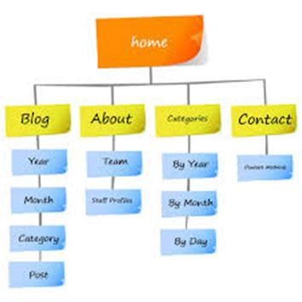
You may see that there are some pages which can perform double duty—rather than writing a page about your ongoing programs for your donors and a second for your volunteers—you might be able to have a single page about your ongoing programs which both donors and volunteers could access for the information.

So begin thinking today about a few main themes that you want to feature in your website.

These main pages may likely become the pages in the menu at the top of your webpage.

They could also represent the way your webpages are organized in the background of your website. So your menus and the way your pages are laid out in the background would be the same.

An example of how pages could be organized in the background of your website:
Here is an example of one way to organize pages. Although this is for our training courses, for your purposes, the headings could just as easily say ‘Ways to Donate’ or ‘Children’s Programs’ and then you could organize related pages nested underneath.
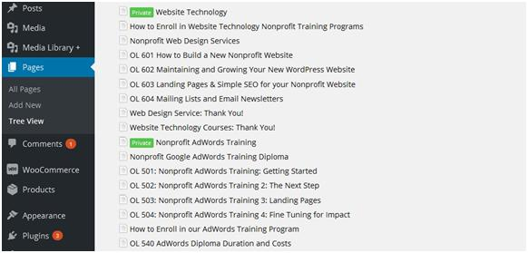

Matching Word Document File Folder Tech Tool: Go to your computer and open up the place where your Word Document files are stored (this could be Windows Explorer or Apple iCloud—whatever). Create the exact same structure as you have in your website's behind-the-scenes page structure (as shown in the illustration above). This will be extremely useful for storing Word documents that you’re going to copy and paste into your website.

Why? In six months you are not going to remember exactly what it was that you wrote as a draft webpage—or where it is stored. Maybe you had some notes or alternate ways of phrasing things that could be useful in the future. Maybe you did some research and found a paper that you quoted on a webpage: store it with your draft webpages.

Also, from a team approach, you never know when you might get that big promotion and a new person comes in and takes your spot. This way they can easily find things.

Example. So here’s what you could wind up with in Windows Explorer. Compare it to the web page structure illustration above (they are exactly the same):
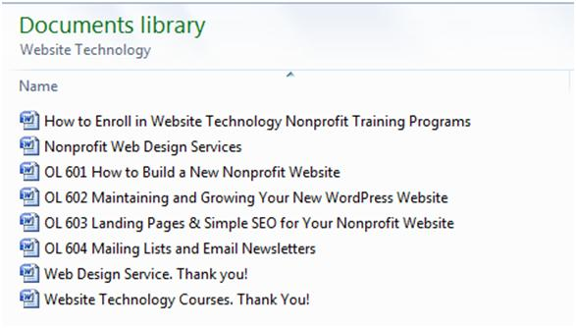
In a year, when you wind up with 100 pages—they can be difficult to find! Organized in this manner—organized like your web pages—makes them much easier to find.

In Summary:
Keep it simple. Choose your main pages (those pages that you might like to have in your menu). Write them onto 3 x 5 cards and tape these to a wall. Add related pages beneath these. See if there is duplicity that could be simplified. Start building your website tree view with the same structure. Do the same with your Word files and folders.

See More Information on Assignment 4.

Homework:
You will not need to turn in a homework assignment this week. Simply send me an email to let me know that you read it. This is just for you to review your website, and clean up any glitches in preparation for assignment five next week. See you then! Copyright © 2019, Tim Magee

