From: Tim Magee: Claremont Food Bank News
Subject: Learn 3 Ways You Can End Hunger in Claremont Today
Preheader: Join a new community of doers, make new friends, support families who are hungry and learn how important our food bank is.

Dear Tim,

Learn how to end hunger in Claremont.
Join a new community of doers, make new friends—and support families in Claremont who are hungry.

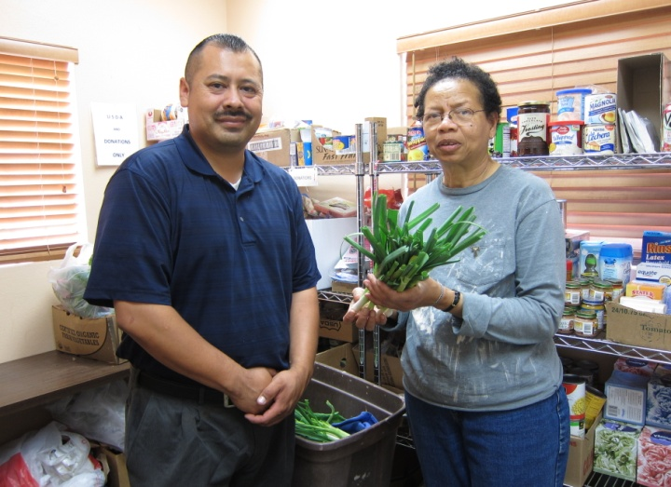 | End hunger in Claremont.  Help members of your community by supporting our food bank:  - Feed the hungry in Claremont  - 200 families a month visit our food bank.  - 52 families have plots in our community garden..  - Volunteer with new friends.  - Donate your extra food to the Claremont Food Bank.
Learn more about how to support the Claremont Food Bank:
Make a gift today, support local families and end hunger in Claremont.

Great People + New Donations = More Families Served
Work together with like-minded people to break the cycle of hunger in Claremont:
- Enjoy the camaraderie of volunteering.
- Develop new friendships in the community.
- Do something meaningful for Claremont with your extra time.
- Enjoy reading our monthly newsletter about your new friends
Learn more about volunteering for our important programs.
Choose the program that’s best for you!

Subscribe: Learn about the families and how to volunteer or donate extra food.
Our people-centered newsletter always includes heartwarming stories about the families that visit our food bank.

Your subscription will keep you up to date on our:
- flexible hours
- multiple locations
- our wonderful staff and tremendous volunteers
- transportation to get you to the food bank
- weekly fresh vegetables provided by our own community garden
Visit our website to learn more about ending hunger in Claremont—and how you can participate too. Subscribe to this informative food bank newsletter.

Contact me directly with any questions. Learn more about our food bank, the people and our programs.

Sincerely,

Tim Magee
Executive Director
Claremont Food Bank

Copyright © 2021, Tim Magee

