Mentored Fundraising Assignment 17 Homework Instructions
6-Month Mentored Nonprofit Fundraising Certificate Program
Center for Sustainable Development. https://nonprofit.csd-i.org/nonprofit-fundraising-training-certificate/

New Section: Email Newsletters. Romance your Subscribers

Assignment 17: Email Subject Lines. Your chance to be both creative and a Sherlock too.

This week’s resources:
Class Home Page for Mentored Fundraising
Fundraising Assignment 17 Homework Instructions

Assignment Seventeen. Email Subject lines. Your chance to be both creative and a Sherlock too.

Okay. You’ve done all the work of setting up beautiful landing pages. You’ve done search engine optimization so that visitors will find your website and subscribe to your newsletter.

You’ve built up an email list of 2,000 subscribers. Good job!

But….. So what?

It’s great that you’re paying an email newsletter service company to send out your 2,000 nonprofit email newsletters every month. But are you benefiting?

What was your goal? What were you hoping to get out of all this hard work? Donations? Volunteers?

So your nonprofit email newsletters need to do several jobs for you. They need to lure subscribers to content that they simply can’t wait to read. But then, both the newsletter and the content (landing page) need to have important calls to action: Donate! Volunteer!

But first, your subscribers need to open and read the newsletter. What’s going to encourage them to do that?

Your subject line.

Your subject line needs to be compelling enough so that people click to open your email newsletter.

It’s a little like looking for keywords using the "voice of the customer." Your subject line needs to be worded in a manner that your subscribers can relate to a short message phrased in their ‘voice.’ If you do a good job they will want to learn more and will click to open your newsletter.

Open up your favorite newspaper online and scan the headlines for the individual articles. The people who write those are geniuses because they all seem tantalizing. Go to your favorite online store and look at the product descriptions: their headlines make you want to buy.

This is your subject line goal too!

I’ve included a few very good resources for subject lines in the resources section just below. Here are some of their conclusions:

1) Keep it short and sweet. It is recommend using subject lines with fewer than 50 characters to make sure the people scanning your emails read the entire subject line.

2) Segment your lists. Send potential donors information interesting to them (and with a subject line interesting them). Send potential volunteers information interesting to volunteers (and with a subject line interesting to volunteers).

3) Use a person’s first name [Dear Tim], or in the Subject line.

4) Let them know what is inside of the email.

MailChimp has several great tools. The MailChimp link in the resources section below guides you to the tools.

One, their Subject Line Researcher, allows you to enter several draft subject lines. The Subject Line Researcher then compares your subject lines to the open rates of subject lines that of actually been sent out and rates which of your subject lines will have a greater likelihood of being opened using a five star rating system.
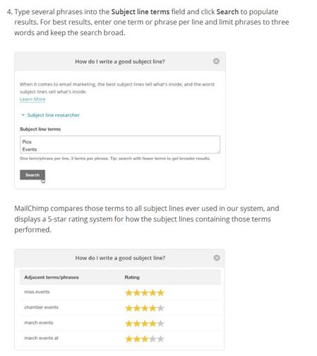

The Wordstream link just below (The 9 Best Email Subject Line Styles to Increase Your Open Rates) describes different styles of writing subject lines that have been shown to be compelling.

See what the pros are doing. One last thing that I would suggest that you do is that when you open your email program in the morning, look at the subject lines and see which ones are compelling FOR YOU. Open a new word document, and copy paste some of the subject lines that lure you into opening an email. And then, the next time you need to write a subject line review this word document and see how your subject line compares to the ones that YOU have liked.

You can even do this with other nonprofits that are related to the type of work that your nonprofit does. If you run a food bank, consider subscribing to nonprofit email newsletters from other food banks and related organizations. Look at their subject lines, look at the subjects of their nonprofit email newsletters, and then look at their landing pages. They might have some great ideas that you can learn from.

In summary, try to keep your subject line below 50 characters, personalize it, let your readers know what they can hope to get, send appropriate information to appropriate subscribers, consider using MailChimp’s subject line testing tool, and keep an eye out for what other professionals are doing with their subject lines.

Email Subject Line Resources:
Google Search: email newsletter subject lines
https://www.google.com/search?source=hp&ei=RQPHXYr5E-7t5gKH8LuQDQ&q=email+newsletter+subject+lines&oq=email+newsletter+subject+lines&gs_l=psy-ab.3..0j0i22i30l7.13615.13615..15124...0.0..0.134.232.1j1......0....2j1..gws-wiz.....0.FMwaDH4JtKI&ved=0ahUKEwjKr6KN393lAhXutlkKHQf4DtIQ4dUDCAc&uact=5

19 Tips & Best Practices for Writing Catchy Email Subject Lines
https://blog.hubspot.com/marketing/improve-your-email-subject-line
The 9 Best Email Subject Line Styles to Increase Your Open Rates
https://www.wordstream.com/blog/ws/2014/03/31/email-subject-lines

Best Email Subject Lines to Boost Your Email Open Rates
https://www.activetrail.com/marketing_blog/email_marketing_articles/best-email-subject-lines-to-boost-your-email-open-rates/

MailChimp: Best Practices for Email Subject Lines
http://kb.mailchimp.com/campaigns/previews-and-tests/best-practices-for-email-subject-lines

The homework to turn in:
1. In your email response to me, send me the topic of one of your upcoming newsletters.

2. What categories is your email list segmented into? Volunteers? Donors? Beneficiaries? University students? Retirees? Include this in your email response to this assignment

3. What segment of your email list are you going to send this newsletter to (in number one above)? Why do you think this newsletter is a good match to that segment? Include these comments in your email response to me.

4. Write three subject lines that you think will be compelling enough so that people in your segmented group will click to open your email newsletter. Paste in your three draft subject lines into your email response

See you next week. Assignment Eightteen: What should your email look like? How long? What will lure subscribers to click through to an actionable landing page?

Tim Magee
Copyright © 2019, Tim Magee

