Mentored Fundraising Assignment 6 Homework Instructions
6-Month Mentored Nonprofit Fundraising Certificate Program
Center for Sustainable Development. https://nonprofit.csd-i.org/nonprofit-fundraising-training-certificate/

This week’s resources:
Class Home Page for Mentored Fundraising
Fundraising Assignment 6 Homework Instructions
Download the PDF Version of this Assignment

Discussion:
This is a fairly technical discussion. If you like, you can simply read and enjoy—and save the ideas for a future date!

Participants in this fundraising training program are quite varied when it comes to Internet technology. Some work with nonprofits that have websites—some don't. Some have website development skills, some don't, and some have IT technicians which handle the website for them.

We are presenting this chapter as a general overview of techniques that you can simply learn about, that you can incorporate into your website if you have the skills—or that can present to your IT technician for incorporation into your website. Or, you can sit down side-by-side with your IT technician and go through the techniques together. You will probably learn a few things—and your technician can decide which to incorporate.

The homework to turn in for this assignment is very simple and does not require you to do any work on your website.

Assignment 6: Installing sign-up forms and popups on your website. Which type? Where? What should they say?
Using forms and popups as a signup conversion technique with new visitors.
Email List Building: How to set up a subscription form with Mail Chimp on your website.

Signup forms are linked to a list. So login in to your MailChimp account:
https://login.mailchimp.com/

Under "Import your list" click on "View lists." You will see the lists you already have.

In the upper left click on "Create list."

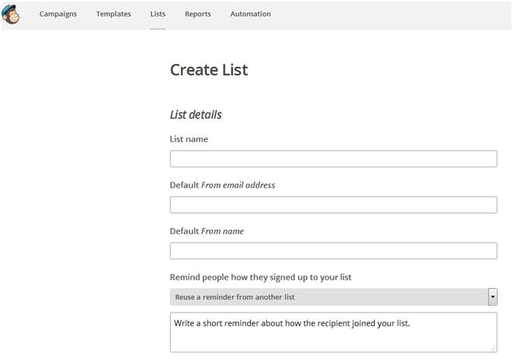

To the form add this information:
- List name
- Default from email address
- Default From Name
- Remind people how they signed up to your list
Click on save.

You will come to a page called "List name and campaign defaults" which gives you the opportunity to fill in a little more information on your subscription notification for new subscribers. You can just use the same "Default email address" from the last form.

Click on save.

You will also receive a List ID number.

To Create a Signup list:
After saving the form information for the new list, click on "Signup forms."

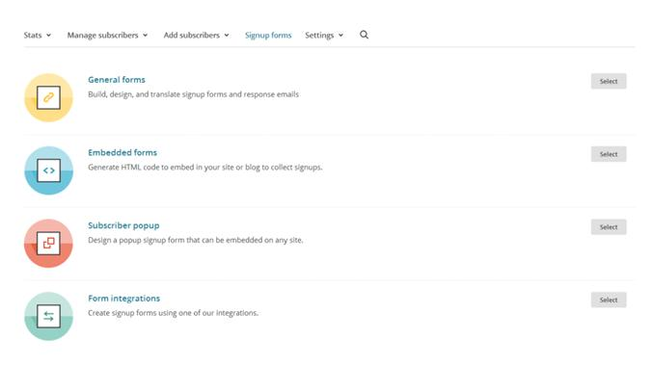

Click on "General Forms. You will see at the very top of the page that you are still in the list that you just created. For example, the top of my page says:
Nonprofit Newsletter from CSDi

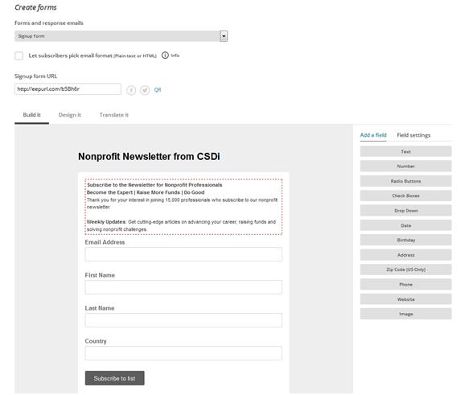

The first thing to do is to write a short note. My example:
"Subscribe to the Newsletter for Nonprofit Professionals
Become the Expert | Raise More Funds | Do More Good

Thank you for your interest in joining 15,000 professionals who subscribe to our nonprofit newsletter.

Weekly Updates: Get articles that provide cutting-edge information that leads you in advancing your career, raising funds and solving nonprofit challenges.

Enjoy! Tim Magee, Executive Director"

Save it.

Then, MailChimp gives you 3 initial fields:
Email Address
First Name
Last Name

And a Subscribe button.

In the left sidebar are other fields that you can add.

Installing the form:
Option 1. You will get a "Signup form URL" in this "create a form page" you are on. You can copy it and use it as the link for your sign up buttons on your website. When people click on your sign up button – they will be sent to MailChimp to fill out the information. And then they will be subscribed.

Option 2.
Open up an existing subscribe page at your website, or, create a new blank subscribe page on your website.

Paste the "Subscribe note" from your signup form into your blank page (whatever way you like doing it so that it looks good):
"Subscribe to the Newsletter for Nonprofit Professionals

Thank you for your interest in joining 15,000 professionals who subscribe to our nonprofit newsletter.

Weekly Updates: Get articles that provide cutting-edge information that leads you in advancing your career, raising funds and solving nonprofit challenges.

Enjoy! Tim Magee, Executive Director"

Now, go back to "Signup forms" (in the upper horizontal menu" and click on "Embedded forms." You will see at the very top of the page that you are still in the list that you just created. For example, the top of my page says:
Nonprofit Newsletter from CSDi

Open up your subscribe page at your website in HTML edit mode. Or, create new subscribe page on your website and open it up in HTML edit mode.

In the MailChimp "Embedded forms" where it says "Copy/paste onto your site" click on the html code and copy it (control ‘C’).

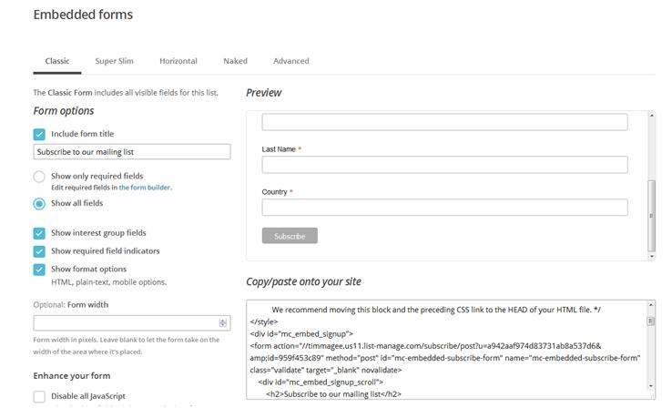

Paste it into your subscribe page on your website in the HTML edit window just below your "Subscribe note" and save it. You can see an example here:
https://nonprofit.csd-i.org/subscribe-to-csdi-nonprofit-newsletter/

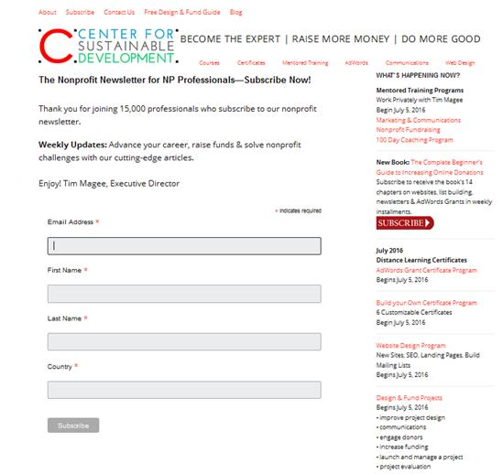

The upper half is a normal content in the webpage. The lower half is Mailchimp’s embedded form.

Opt-in confirmation:
Back at General Forms, under create forms, in the dropdown list click on "opt-in confirmation email."

In the form you can personalize what MailChimp has written. For example:

"Please Confirm Your CSDi Newsletter Subscription

Thanks for signing up for our CSDi newsletter for nonprofit professionals.

Can you please confirm your email address by clicking on the link above.

This will give us permission to send you the newsletter. There is nothing else for you to do.
Thanks again—and enjoy!

Sincerely,

Tim Magee"

Now go back to the top drop down menu and click on "Confirmation ‘thank you’ page."

If after confirming their subscription, you would like your new subscriber to receive a thank you note, just edit the one in this form.

If that seems like too many emails, and you would like them to return to your site, enter one of your webpages into the cell below where it says: "Instead of showing this thank you page, send subscribers to another URL."

This can be to a landing page where maybe they will donate—or it can be to a simple thank you page like this one:
https://nonprofit.csd-i.org/thank-you-for-subscribing-to-nonprofit-newsletter/

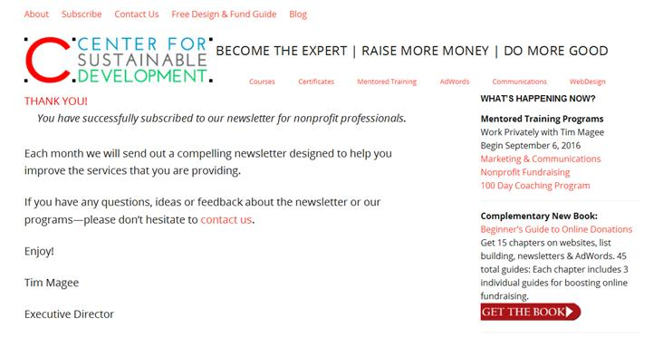

It is a good idea to send a new subscriber back to page on your website to keep up the engagement process. You could send them to thank you page (as above), to a donation page, or to your blog that features latest information-packed newsletter.

Don’t close the MailChimp windows yet.

Double Check.
OK! You have just complete setting up a legitimate opt-in subscription form on your website. Congratulations!

Just double check that it works and that it looks good.

Go to your subscription page and subscribe! See what happens.

If it worked, you should get a confirmation email. Does it look OK? Is it clear?

If so—great! If not, while your MailChimp form is still open you can make edits and corrections.

Good Job!

The final proof will be when you get a "New Subscriber" notification from MailChimp with your name.

How to Set up Pop-Ups for Newsletters on Your Website.
Now that we’ve worked so hard getting people to visit your website, we need to make sure that qualified visitors sign up for your email list.

Not many people randomly sign up for newsletters after having landed at a website. They need some encouragement.

Two of the most effective things that you can do are to have pop-up subscription forms and/or to offer something for free.

You might personally find pop-up subscription forms annoying, but they have proven to be highly effective. Plus, you can make them not too terribly obnoxious.

Much like website companies, there are hundreds of pop-up organizations out there. I’m going to introduce you today to one called Sumo. It’s free, flexible, and fairly easy to set up.

Step 1. In WordPress, click on install new plug-ins and search for Sumo. Install it, and activate it.

Step 2. You will find that there is a new blue ‘thingy’ in the top right of your WordPress site. It just looks like a small blue line but when you hover over it a blue crown appears: click on it. Then register with Sumo.

Step 3. After signing in you’ll be taken to the Sumo Store. They have a number of tools that you can take advantage of. But today we’re focusing on pop-ups. They have two kinds of pop-ups: List Builder and Scroll Box.

List Builder causes a pop-up to appear on the visitor’s screen when they do one of several actions—such as move their mouse cursor to the top right like they’re going to "X" out of your site. You can choose which actions will activate the pop-up. You can customize the pop-ups with graphic tools and make them different sizes as well.

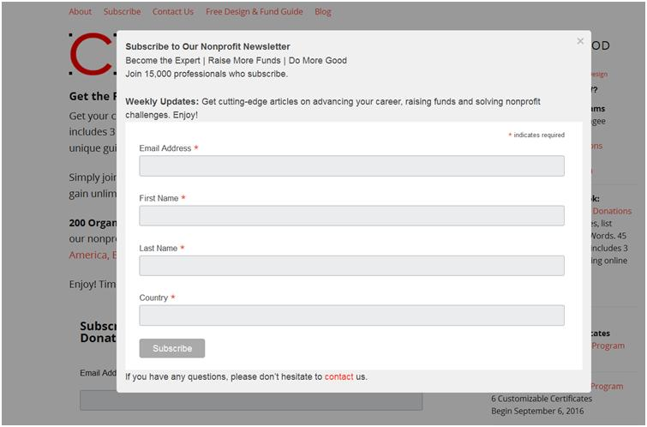

Scroll Box works like this: when somebody begins reading one of your webpages, as they scroll down and begin approaching the bottom of the page, Scroll Box will activate a pop-up that slides in from the side like this:

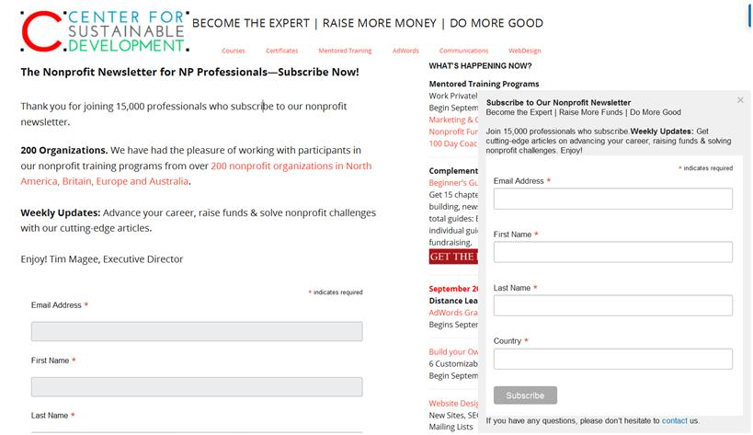

Step 4. When you click on List Builder or Scroll Box you’ll be taken to a page where you can set up your pop-up.

Off in the left sidebar, click on "Behavior." This begins the process of letting Sumo know when to activate the pop-up.

Under "Services" you can select the email list building service provider that you use—for our example we would select MailChimp. This means that Sumo isn’t actually collecting names, it’s simply providing the pop-up—and MailChimp is doing collection of names.

Under "Advanced" you can determine the size of the pop-up. But this is also where you paste in your subscription form.

Do you remember how earlier in this week’s chapter we went into MailChimp, clicked on "Sign-Up Forms", and then "Embedded Forms" and copied the HTML code for your sign-up form and pasted the code into your website’s subscription page?

We’re going to do the same thing here with Sumo.

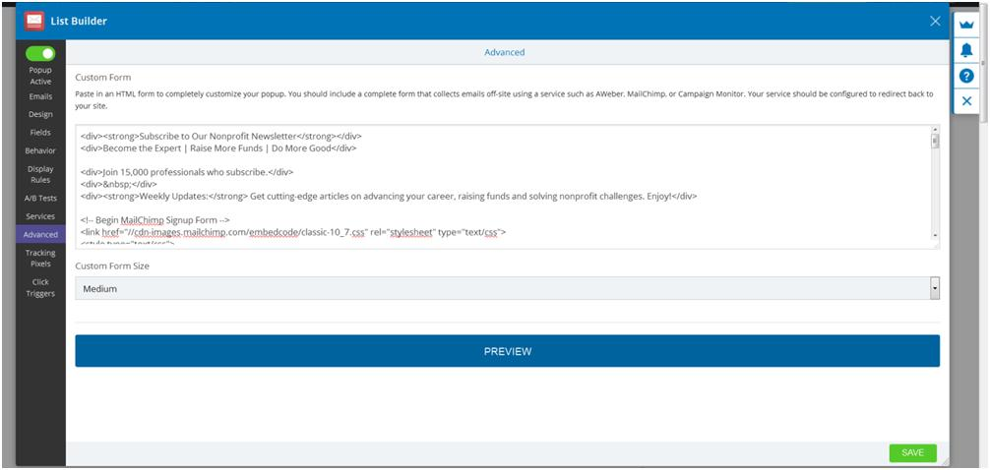

I want to keep track of how I’m getting sign-ups, so I’ve actually created a new list in MailChimp called Scroll Box. That way when someone subscribes to the newsletter through the services of a pop-up it shows up in this mailing list and so I can see how effective it’s being.

After you’ve created the new list and it’s sign-up form—exactly like we did in the first part of this week’s exercise, you can paste the Embedded Form's HTML into this "Advanced" location in Sumo—and you’re done!

Please Note: You don’t need to create a new list from scratch: you can simply replicate the list that you made in the first part of this chapter and just save it under a new list name. You can do that in one minute and copy the HTML from embedded forms and paste the code right into Sumo.

Once your pop-up is working on your website you can fine tune it to make it bigger, smaller, more colorful, less colorful and you can even change the copy back in MailChimp if you don’t like what it says.

In Summary:
If you don’t already have a service for popups check out our recommendations.

Also, you can research other possibilities on Google, and ask your nonprofit friends.

There is a small learning curve to signing up for these programs and launching your first popup—but it’s not too tough—and they all have tremendous support systems. So get going!

Homework:
Just send me a short email with:

1) Are you currently using popups on your website—and what/who is it?
2) What are you asking visitors to do with the popups (calls to action)?
3) If so—are they working for you?

See you in Assignment 7!

Copyright © 2019, Tim Magee

