Mentored Fundraising Assignment 16 Homework Instructions
6-Month Mentored Nonprofit Fundraising Certificate Program
Center for Sustainable Development. https://nonprofit.csd-i.org/nonprofit-fundraising-training-certificate/

Assignment 16: SEO Optimization: Keywords, Writing and Content Marketing.
12 steps to building a perfect landing page template.

This week’s resources:
Class Home Page for Mentored Fundraising
Fundraising Assignment 16 Homework Instructions

Assignment Sixteen. Demystifying SEO Optimization: Keywords, Writing and Content Marketing. Use Yoast SEO Optimization to insert keywords into your headings, page title, page description and content. Post information rich, long content.

The way that search engines work. Search Engine Optimization (SEO). Yeesh. Sounds daunting doesn’t it?

When a potential donor is looking for a local food bank they might type in something like "food banks in Claremont."

Google has visited your website over time and has stored information about your individual pages. If you have a page with words that say "food banks in Claremont" Google will make the connection between that potential donor’s search and your food bank page.

We learned in Assignment 12 that this is all driven by the words that searchers use to search for food banks and the matching words on your web page.

If you’ve done a good job of researching the search terms that potential donors have been using to find your site, then you should have a good trove of keywords at your disposal for your different landing pages.

Yoast SEO Optimization encourages you to use these keywords on webpages in a manner that will be most relevant to Google and that will encourage them to post a link to your page on the potential donor’s search results. This is called ranking: "you ranked the first page."

As this is a beginner’s guide I’m going to keep this as simple as possible. Please bear in mind that there are several levels of sophistication beyond what we will discuss here that I encourage you to explore. I will post a series of links at the end of this chapter to help you with those explorations.

What is your goal?
My guess is that as a nonprofit you’re hoping to increase donations, increase your volunteer base, and grow your newsletter mailing list.

What Yoast SEO Optimization allows you to do is to target specific pages to specific searches that potential donors are conducting. So you want a single page to be focused on a single concept and a single focused keyword or keyphrase—and to have information to share which is specifically relevant to that concept and keyword.

One concept, one page.
If you feel this is too limiting, I'll suggest three things. One, if you’re struggling with the fact that you have three concepts that you would like to present on a single page, consider creating three pages instead.

Two, check out some of the resources that I’m providing at the end of the chapter and look at how much information many of them provide on a single page. You’re not limited by how much information you can provide on a page that’s geared to a single focus keyword, it’s just that all of that information needs to relate to the focus keyword. Many of the pages that you can look at in the resources below have an excess of 2000 words—they just relate to that one topic.

Three, the Premium, paid version of Yoast shows you how to have up to five focus keywords per page.

So something that I would be tempted to do would be to expand upon the chart that you began in Assignment 12 where you listed your programs and their a potential keywords.

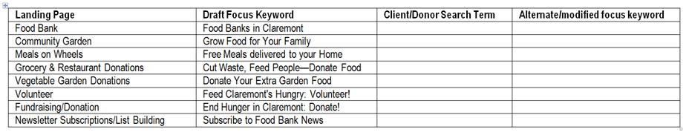
Continue to maintain and expand this Excel spreadsheet as you come up with new ideas for new information about a specific topic.

So for example, since we’ve been focusing on newsletter subscriptions, you could have additional landing pages that are informational pages relating to the newsletter subscriptions that have their own focus keywords. It could look something like this:
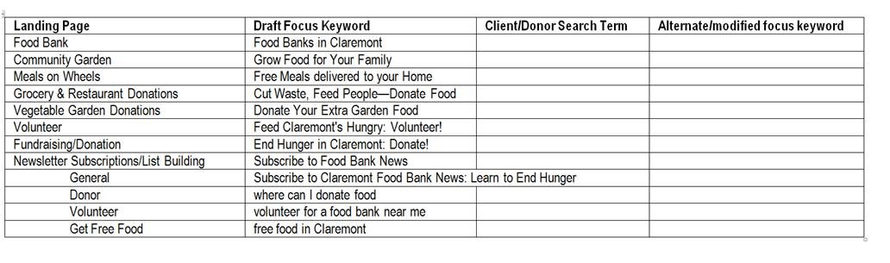
So you can see that you can take what may have been a general landing page about subscribing to a food bank newsletter and create four specialized pages. Each has their own focus keyword, and their own relevant supporting information. This isn’t that difficult to do, you can simply copy the ‘general newsletter’ page onto a new ‘donor newsletter’ page, research and effective keyword for that page, and then edit the content to support that keyword.

Searches are almost always intended to discover information on a single subject. So organize your landing pages and their focus keywords into ‘buckets’ of intent.

So, now, rather than simply having one page attracting general supporters for your nonprofit, you can have four pages working away for you—even while you sleep!

You could even let these four new pages do double duty for you by using them as a individual newsletters.

How do you begin optimizing your webpages with SEO Tools?
So now the hard part is over: you have chosen a specific topic and researched and chosen a focus keyword—and have begun writing content for a page.

For the rest the assignment we’re going to begin going through some simple SEO Optimization techniques that you can do in a few minutes. You’ll find that these techniques follow the Assignment 14 landing page checklist very closely. If you have installed the Yoast SEO Optimization plug-in for your WordPress site—then this SEO work will be a snap.

So let’s get started.
First: Start a master Excel spreadsheet which lists your existing webpages with their page titles and their focus keywords. Each time you develop a new webpage add it to this spreadsheet along with its focus keyword. This will help you keep from duplicating keywords.

Use WordPress’s SEO Optimization plugin ‘Yoast’ to quickly and efficiently manage SEO.
Now, open up your new landing page in editing mode in WordPress. Scroll down to the bottom to Yoast’s SEO Optimization Tools. It will prompt you to make some optimizations.

You probably did most of the background work for this in Assignment 12, but Yoast’s SEO Optimization Tools will prompt you to make some refinements and to optimize your SEO.

1. Focus keyword.
In Assignment 12 when you did your keyword research for the new landing page, you were able to use that information to develop the page title. You should also have come up with a focus keyword for the landing page which will be the main keyword on the landing page that Google will lock in on.

The focus keyword should be a keyword that you saw people using over and over again that you discovered while researching your page title. This will indicate that other organizations who have done keyword research and found the importance of using that keyword: you can use it to!

In the advanced keyword research techniques that you used in Assignment 12, I showed you how to find search terms that real people are using; this is called the voice of the customer. This should also be very helpful for you in choosing your focus keyword.

Finally, you want your focus keyword to clarify an Internet searcher's focus so that they will have a valid reason for visiting your website. For example, if they were to use the focus keyword ‘food,’ it would be highly competitive with other people using the word food. This could include grocery stores and restaurants—so you might have trouble showing up on the first page when so many other people are using that keyword. Also, you might get a much higher number of unqualified visitors to your website.

By simply making your focus keyword two or three words long, you can reduce the competition and give people a better idea that your site is exactly what they’re looking for.

So by simply changing my focus keyword from ‘food’ to ‘food bank’ or ‘food pantry’ I will get out of competition with restaurants that are also using the word ‘food’ and let Internet searchers more specifically know what it is that I have to offer on my landing page and in my organization.

2. Page Title.
You did quite a bit of work to find the best title for your landing page. Yoast’s SEO Tools are going to make sure that it is the right length and that it contains your focus keyword. It will also suggest that your focus keyword is near the front of the title.

The title can only be a total of 65 characters to fit in a Google Search:
Subscribe to Claremont Food Bank News: Learn to End Hunger | CSDi (65 characters).

This includes your website title which in my case is CSDi and is automatically inserted.

Therefore, in my case, my page title can only be 58 characters:
Subscribe to Claremont Food Bank News: Learn to End Hunger (58) + | CSDi (7) = (65 total characters including spaces).

3. Meta-description.
The meta description is what shows up in Google search results. Therefore, a catchy title and your compelling description will make or break a searcher’s decision to click through to your website.

Your meta description can only be 156 characters and needs to contain your focus keyword:
End hunger in Claremont. Join a community of doers & support families in need. Subscribe to Food Bank News & learn the benefits of donating & volunteering. (155)

The meta description should quickly and compellingly encapsulate what you’re trying to accomplish on the landing page—and include a call for action.

I usually have my meta-description do double duty: I’ll also use it as an opening tag line on the landing page or as a compelling lead-in for the first call to action on the landing page. You can see that I’ve done this in my second call to action to subscribe on this landing page:
https://nonprofit.csd-i.org/subscribe-to-claremont-food-bank-news/

I find that by inserting my meta-description into the landing page itself I can see it clearly, and in context. Sometimes this prompts be to make minor changes which actually improve the meta-description.

4. URL.
The reason that I have been encouraging you not to publish your landing page all this time that you’ve been working on it, is because we want to make sure that your URL is perfect.

Google remembers all of your URLs. If you publish your page too early and later decide you don’t like your URL—and change it—Google will wonder what happened to the first URL that you had published and may even send you an error message.

So, by holding off publishing your page until you've done your keyword research, discovered what your focus keyword is and written your meta-description—you can use them to help get your URL just the way you like it before you hit the publish button.

Your URL should be relatively short, should contain your focus keyword, and should be a very short description of what your landing page will offer to a visitor. This will give credibility to your search results. For example, if you’re offering a free guide to food banks and your URL says " http://nonprofit.csd-i.org/pay-here-for-the guide/" it’s going to make people think twice.

Perhaps this would be better: 'http://nonprofit.csd-i.org/subscribe-to-claremont-food-bank-news/' .

So you want your URL to be consistent with what it is they’re hoping to find if they click on your landing page link.

Yoast’s SEO Optimization Tools will prompt you with ways to improve your URL prior to publishing.

5. H1 headline. H2 headline.
At the very top of your landing page you will typically see a main headline and a subheading.

If you are building your individual pages in visual editing mode, you can write your headline at the top, and in a drop-down menu format it as a heading one or a heading two heading.

If you are building your individual pages using HTML, you simply put your headings in heading tags: <h1>, <h2>

One of your two headings needs to contain the focus keyword.

6. Focus keyword in the page’s content.
Yoast’s SEO Optimization Tools will prompt you to make sure that you include your focus keyword in your title, your page header (h1, h2) your meta-description, the first paragraph of your landing page and that it is included enough times in the content of your landing page that it will be between 2% and 5% of the words.

7. Alt attributes for images.
This is a little more of an advanced technique. Since Google can’t "read" photographs it likes to see a text description of the photograph.

In the visual editing mode you can select a photograph that you’ve inserted and click edit. You’ll be shown a box where you can enter ‘Alternative text.’ You can type in a text description of the photo: make sure you include the focus keyword.

In the food bank subscription landing page example that we’ve been using, I put in alternative text that says "Isaac Vega and Client in the Claremont Food Bank."

The alternative text is invisible on your webpage.

8. Number of words on a page.
It is generally acknowledged that webpages with more than 2000 words perform better than shorter pages. Pages of this length are rich with information and useful words. Google likes this and will increase your ranking accordingly. Also, serious Internet searchers finding authoritative pages such as this may learn a lot about what they’re hoping to find and may insert a link to your page from their website (like I've done at the end of this assignment with other expert sites). These are called backlinks and Google likes backlinks too.

Yoast’s SEO Tools provide a prompt for you that lets you know how many words are in your post and if you’ve exceeded their minimum of 300 words.

When you are done, the Yoast Results will look like this:
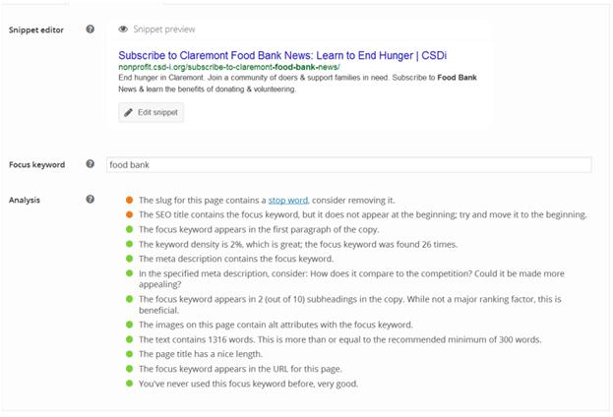
Advanced Resources for SEO Optimization Tools:
SEO vs. PPC – Which Provides You the Better Value?
https://www.newmediacampaigns.com/page/seo-vs-ppc—which-provides-you-the-better-value
This is an interesting study about points out that organic search results are more effective than PPC search results.
Targeting Multiple Keywords vs. Singular Keyword Focus
https://moz.com/blog/targeting-multiple-keywords-vs-singular-keyword-focus
Interesting article looking how to determine if it’s effective targeting more than one focus keyword on a webpage.
What Is The IDEAL Keyword Density Percentage To Improve Rankings in Google in 2019?
https://www.hobo-web.co.uk/keyword-density-seo-myth/
14 of the Best SEO Tools for Auditing & Monitoring Your Website in 2019
https://blog.hubspot.com/marketing/seo-analysis-tools
Pretty Cool
The Ultimate Guide to SEO for E-commerce Websites
https://blog.kissmetrics.com/seo-for-ecommerce-websites/
Very Cool
Moz Pro | Keyword Explorer and SERP Analysis Tool
https://moz.com/tools/keyword-difficulty
Paid service with a free trial—there may be others out there that are free
7 Tips to Optimize Your Landing Page for Search Engines #SEO
https://blog.getresponse.com/7-tips-optimize-landing-page-search-engines-seo.html
Very good and healthy basic overview. Also has a downloadable document on growing your mailing list.
Google search: choosing best keywords for landing pages for SEO
https://www.google.com/search?source=hp&ei=KvAAXa64MMbN_AaNs57wCw&q=choosing+best+keywords+for+landing+pages+for+SEO&oq=choosing+best+keywords+for+landing+pages+for+SEO&gs_l=psy-ab.12..33i299j33i160.712.712..7106...0.0..0.262.385.0j1j1......0....2j1..gws-wiz.....0.HYZsaWKJSYI
The Landing Page Optimization Process [Infographic]
https://unbounce.com/landing-pages/landing-page-optimization-process/
Landing Page Optimization: What You Should Be Testing and Why [Infographic]
https://www.marketing-mojo.com/infographic/landing-page-optimization-infographic/
Google search: optimizing for several focus keywords on a landing page
https://www.google.com/search?source=hp&ei=ivAAXajGI6SZ_QaB87fwDA&q=optimizing+for+several+focus+keywords+on+a+landing+page&oq=optimizing+for+several+focus+keywords+on+a+landing+page&gs_l=psy-ab.12..33i299.647.647..1614...0.0..0.342.459.0j1j0j1......0....2j1..gws-wiz.....0.gwljukTWytY
Meta Tags – How Google Meta Tags Impact SEO
https://www.wordstream.com/meta-tags
On-Page SEO 101: Tips for Keyword Optimizing the Most Critical Parts of Your Website
https://blog.hubspot.com/marketing/seo-site-keyword-optimize-ht
Excellent
Why My Optimized Landing Pages Trump Your SEO Or PPC Landing Pages Every Time!
https://searchengineland.com/why-my-optimized-landing-pages-trump-your-seo-and-ppc-landing-pages-everytime-167430
Very Good Basics: check for 5.1
Hubspot Website Grader
https://website.grader.com/?__hstc=20629287.ce2a58ab76265b9eb4ee1f2ae4c85712.1469474452798.1469477970938.1469489154732.3&__hssc=20629287.2.1469489154732&__hsfp=3012175910#/
Looks cool
21 Actionable SEO Techniques
https://backlinko.com/seo-techniques
Excellent
16 Powerful SEO Copywriting Secrets For More Traffic (Fast!)
https://backlinko.com/seo-copywriting
Very Good Basics
The homework to turn in will:
1. Choose the best focus keyword for your new landing page based upon your keyword research from assignment 12. Remember: use the 'Voice of the Customer' (VOC) during your selection process. Copy this focus keyword into your email response to me.

2. Write a page title using your focus keyword that lets your visitor know that your search result is what they're looking for. Copy this page title into your email response to me.

3. Write a meta-description using your focus keyword that quickly and compellingly encapsulates what you're trying to accomplish on the landing page—and includes a call for action. This could be a refinement of the call to action that you wrote in Assignment 14. You can use this as the first paragraph in your landing page—or insert it adjacent to your call to action button. Copy this meta-description into your email response to me.

4. Write a URL that includes your focus keyword and lets a potential visitor know that they're going to be sent to a landing page appropriate to what they're searching for. Copy this URL into your email response to me.

See you next week. Assignment Seventeen. Email subject lines. Your chance to be both creative and a Sherlock too.

Tim Magee
Copyright © 2019, Tim Magee

