Mentored Fundraising Assignment 20 Homework Instructions
6-Month Mentored Nonprofit Fundraising Certificate Program
Center for Sustainable Development. https://nonprofit.csd-i.org/nonprofit-fundraising-training-certificate/

This week’s resources:
Class Home Page for Mentored Fundraising
Fundraising Assignment 20 Homework Instructions
Read '12 Steps to Building a Perfect Landing Page Template'
Download Fundraising Assignment Twenty Word Version of Revised Landing Page

Assignment 20: Final edit of and connection between your newsletter and your landing page.
Over the past few weeks you have perfected a landing page and created a new newsletter template from that landing page. However, you have made a number of changes and then performed a lot of copying and pasting.

So this week we're going to go through the newsletter and its matching landing page, ensure they are parallel, and then fix any errors. We will also double check our call-to-action buttons and links—and then do a thorough proofread. So this becomes a last minute checklist that you should do each and every time you are about to send out a newsletter. It will become second nature and you will be able to do it quickly.

You can also reread '12 Steps to Building a Perfect Landing Page Template' as a refresher.

PART 1. Make sure that your newsletter and your landing page templates are dovetailed together for ensuring that there is consistency between what the reader reads in your newsletter and finds on your landing page.
PART 2. Incorporate a call to action in both the newsletter and in your landing page: convert visitors into donors.
PART 3. Final check: Proof read, Yoast SEO, mobile friendly format, readability (send samples to different devices), check links, and check payment systems.

PART 1. Make sure that your newsletter and your landing page templates are dovetailed together
If an Internet searcher has found your organization using keywords, and those keywords appear in your search results—when they click on your link and land on your landing page—they want to know immediately that they are on the correct page—the page that answers their search query.

If one of your subscribers receives a newsletter that is interesting to them—if they click on your call-to-action link and land on your landing page—they want to know immediately that they are on the correct page—the one that fulfills their interest.

So my suggestion is to open up your newsletter and your landing page side-by-side in your monitor and make sure that they are absolutely in agreement. Titles should be the same. Information should be about exactly the same subject.

If they aren't in perfect correlation, what I like to do is to print the newsletter and the landing page out—and lay them side by side. Using a red pen, I can make minor adjustments to make them absolutely parallel. This can be done in a few minutes.

My First Problem
For example, my landing page's headline says "Subscribe to Claremont Food Bank News." This was the intention for the original campaign from weeks ago.

However, in assembling my newsletter, after I reviewed my supporter research and my subject line research I realized that I needed a more compelling subject line.

The improved subject line on my newsletter says "Learn 3 Ways You Can End Hunger in Claremont Today." So I need to bring those two elements into correlation.

I will change my Landing Page Headline to say: "Learn 3 Ways You Can End Hunger in Claremont Today."

My Second Problem
The second problem that I see is that although I copy/pasted information from the landing page directly into the newsletter, it is presented in a more condensed format in the newsletter. Upon opening the newsletter the subscriber immediately sees that the three ways to end hunger in Claremont are to 1) donate, 2) volunteer, and, 3) subscribe to the newsletter to stay up-to-date on the food bank.

Since the landing page is much longer than the condensed newsletter, these three concepts are spread throughout the landing page—so a visitor doesn't see the three options right away like they saw in the newsletter.

So I will need to add a short sentence at the very top of the landing page showing the three support options and why they will help end hunger in Claremont.

So I changed my Landing Page Sub-Headline to say: "Donate, Volunteer & Subscribe to Our People-Centered Claremont Food Bank News."

These two changes only took me a few minutes to do and solved the problem. The Newsletter and the Landing page are now parallel to each other.

You can see the improved landing page here. You can see the newsletter here.

Here is an illustration of the two documents:

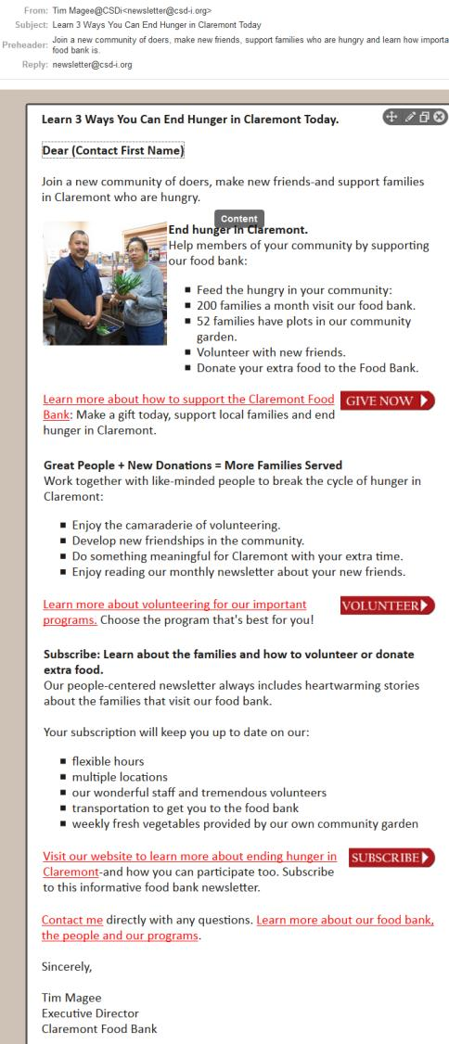 | 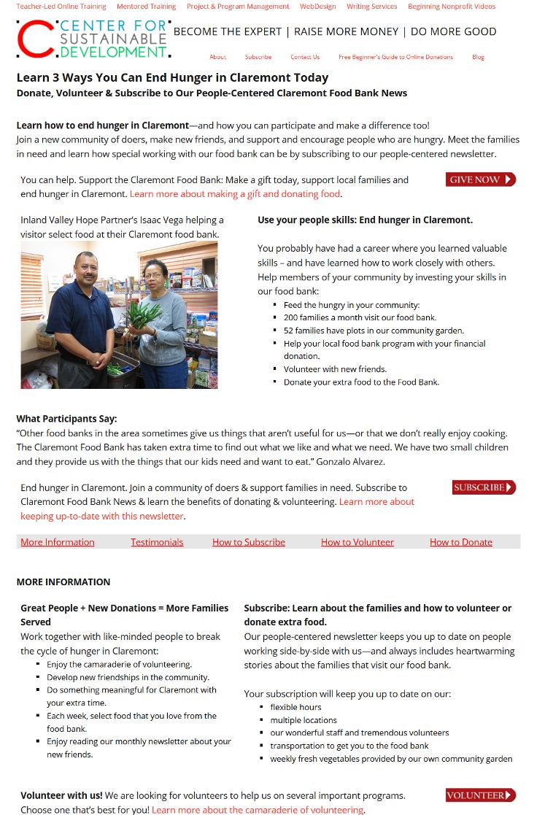

PART 2. Incorporate a call to action in both the newsletter and in your landing page. This is a 3-step process.
Sending someone a newsletter presents a two-step process to getting a donation. The subscriber needs to be 1) compelled by your subject line to open your newsletter and then out of interest 2) click on the link to your landing page.

The landing page then presents the 3rd step: it needs to be compelling enough to get the donor to 3) click on "Donate!"

YOUR NEWSLETTER SHOULD HAVE:
1. A subject line that will get people to open your newsletter. So double check your subject line and make sure that it will compel subscribers to open the email. Many email service providers have a tool that you can paste your subject line into and they will rate it and present alternatives if necessary.

2. The newsletter should be interesting to the subscriber. The interesting subject should present a bit of a cliffhanger (a hook) so that the reader will be compelled to click through to your landing page to learn more.

3. A compelling call to action—with a button:
You can help. Support the Claremont Food Bank: Make a gift today, support local families and end hunger in Claremont. Learn more about making a gift and donating food.

When you are happy, send yourself the email newsletter. Open up your newsletter in a couple of browsers to make sure it works and looks good. Open it up your in your smart phone to make sure it works and looks good.

YOUR LANDING PAGE SHOULD HAVE:
1. Information sufficient for a visitor to make a decision without leaving the page. Our Approach: Above the fold (the fold is the bottom of your computer screen) we put the important, immediate information to let a visitor know that 1) they’re on the right page, 2) we have the quality product they’re looking for, 3) they have a call to action to respond to immediately, or 4) they realize this is definitely interesting but that they want to learn more before making a decision.

Two-Step Landing Page Solution: So one thing that we found works well for us is a two-step landing page. What we do near the bottom of the fold is to put in a series of horizontal tabs that are links leading to additional information further down the page. Ideally this row of horizontal tabs would appear just above the fold, but the information they contain could be below the fold.

You don't want to overwhelm the landing page visitor with too many distractions and too much information above the fold. However, the information above the fold should be sufficient enough for them to actually make a decision to click on "Donate!" if they are ready.

If there's still not ready, they can click on one of the tabs at the bottom of the fold to get additional information without actually leaving the landing page.

2. A compelling call to action—with a button:
End hunger in Claremont. Join a community of doers & support families in need. Subscribe to Claremont Food Bank News and learn the benefits of donating and volunteering. Learn more about keeping up-to-date with this newsletter.

PART 3. These final steps need to be taken in both the newsletter and the landing page. Final check: Proof read, Yoast SEO, readability (send samples to different devices), check links, and check payment systems.

1. Proofread. WordPress has automatic grammar and spell checking. This really speeds things up.

2. Check that your SEO is still optimized. If you made some changes to your landing page in Part 1 to better match newsletter, it's possible that it could have caused some problems with your SEO. Yoast is so quick and easy to work with that you can see in an instant that (for example) your keyword is now missing from your page title, or that the number of times you've used your keyword in the body of the landing page is no longer sufficient. You can check this very quickly.

3. Readability. It's been a couple of weeks since you wrote landing page, now would be a good time to read through it again to make sure that it still makes sense. If possible, it's great if you can get a colleague to read through it to see if you missed anything.

When you are happy, open up your landing page in a couple of browsers to make sure it works and looks good.

4. Check links. This is absolutely imperative. I know this can be a tad boring—but you need to do it. One thing that I find really speeds it up is to put your cursor over a link or button and right-click on it and then select "Open link in new tab." This saves a lot of cycle time. So if the correct page opens in a new tab, can just delete it and go right back to your main landing page—without having to go through the time it takes to cycle back to the landing page. In other words, the landing page stays open full time while linked pages just open and close different tab.

5. Check payment systems. Even more imperative. It's really just one click see if the donation form is working.

When you're happy, send a sample of your newsletter to two different email programs (i.e. Gmail and Outlook). Open both your newsletter and your landing page and your cell phone to make sure they work and look good.

The homework to hand in through your email to me:
1. Just send me a short sentence on if you needed to make modifications on your landing page like I did.
2. And just send another short sentence saying that you went through the checklist and feel you are ready to go.

That’s it! Get going!
See you next week. Assignment Twenty One: Launch/Promote. Send it! Track your performance over the first week and watch it grow. List what you would do better next time. Copyright © 2019, Tim Magee

