Become the Expert | Raise More Money | Do More Good

Learn 3 Ways You Can End Hunger in Claremont Today
Donate, Volunteer & Subscribe to Our People-Centered Claremont Food Bank News

Learn how to end hunger in Claremont—and how you can participate and make a difference too!
Join a new community of doers, make new friends, and support and encourage families in Claremont who are hungry. Meet the families in need and learn how special working with our food bank can be by subscribing to our people-centered newsletter.
You can help. Support the Claremont Food Bank: Make a gift today, support local families and end hunger in Claremont.
Learn more about making a gift and donating food.

Inland Valley Hope Partner's Isaac Vega helping a visitor select food at their Claremont food bank. | Use your people skills: End hunger in Claremont.:
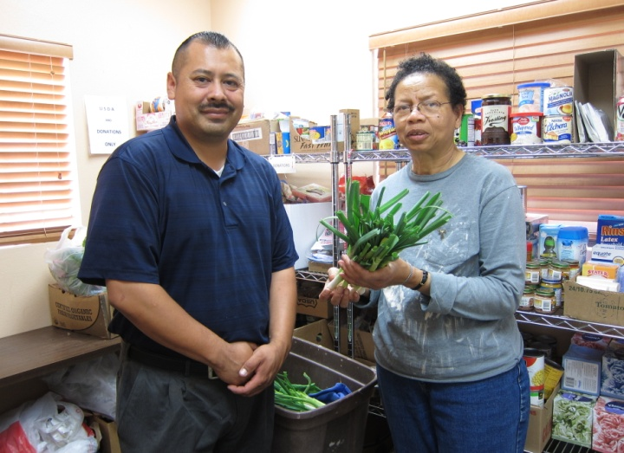 | You probably have had a career where you learned valuable skills – and have learned how to work closely with others. Help members of your community by investing your skills in our food bank:  - Feed the hungry in Claremont  - 200 families a month visit our food bank.  - 52 families have plots in our community garden.  - Help your local food bank program with your financial donation.  - Volunteer with new friends.  - Donate your extra food to the Claremont Food Bank.

What Participants Say:
“Other food banks in the area sometimes give us things that aren’t useful for us—or that we don’t really enjoy cooking. The Claremont Food Bank has taken extra time to find out what we like and what we need. We have two small children and they provide us with the things that our kids need and want to eat.” Gonzalo Alvarez.

End hunger in Claremont. Join a community of doers & support families in need. Subscribe to Claremont Food Bank News and learn the benefits of donating and volunteering. Learn more about keeping up-to-date with this newsletter.

More Information | Testimonials | How to Subscribe | How to Volunteer | How to Donate

MORE INFORMATION
Great People + New Donations = More Community Members Served  Work together with like-minded people to break the cycle of hunger in Claremont:  - Enjoy the camaraderie of volunteering.  - Develop new friendships in the community.  - Do something meaningful for Claremont with your extra time.  - Each week, select food that you love from the food bank.  - Enjoy reading our newsletter about your new friends each  - month. | Subscribe: Learn about the families and how to volunteer or donate extra food.  Our people-centered newsletter keeps you up to date on people working side-by-side with us—and always includes heartwarming stories about the families that visit our food bank.  Your subscription will keep you up to date on our:  - flexible hours  - multiple locations  - staff who are helpful, understanding community members  - transportation to get you to the food bank  - weekly fresh vegetables provided by our own community garden
We are looking for volunteers to help us on our important programs. Choose the one that’s best for you! Learn more about the camaraderie of volunteering.

Back to top.

WHAT PARTICIPANTS SAY:
“I have three growing children and I’m concerned about the food that we can buy: it’s very expensive and it isn’t always healthy. Working at the Claremont Food Bank community garden we can grow organic vegetables, and eat healthy fruits and vegetables that we were used to in Central America. The Claremont Food Bank’s community garden helps us eat healthy food that we like.” Maria Alonso.

Back to top.

SUBSCRIBE TO FOOD BANK NEWS: The Nonprofit Newsletter for NP Professionals—Subscribe Now!
Thank you for joining 15,000 People who subscribe to our nonprofit newsletter.

Weekly Updates: Learn How we solve hunger in Claremont—and how you can participate too—in this informative newsletter.

Enjoy!

Tim Magee, Executive Director

Email Address *

First Name *
Last Name *
Country *

You will now find a confirmation email in your inbox. Just click on the link to confirm your subscription. Thank You!
If you have any questions, please don’t hesitate to contact us.

Each week you will receive articles on subjects that readers like you have requested:

Enjoy!

Tim Magee
Executive Director
Claremont Food Bank
Back to top.

VOLUNTEER WITH THE CLAREMONT FOOD BANK: NOW!
The Claremont food bank has just completed 15 years of providing food to families in need in Claremont and surrounding communities.

We’re very enthusiastic about the success of this project—and wish to continue to grow so that we can serve more people need.

We are looking for volunteers to help us on several important parts of our program. Choose one that’s best for you!
- working in the food bank two mornings a week
- delivering food packages to at-home clients
- bringing clients without transportation to the food bank
- collecting food from restaurants and grocery stores
- participating in quarterly food drives

Great People + New Donations = More Community Members Served
Work together with people like you to break the cycle of hunger in Claremont:
- Enjoy the camaraderie of volunteering.
- Develop new friendships in the community.
- Do something meaningful for Claremont with your extra time.
- Each week, select food that you love from the food bank.
- Enjoy reading our newsletter about your new friends each month.
If you are considering participating, did you know that we have:
- flexible hours
- multiple locations
- staff who are helpful, understanding members of the community
- transportation to get you to the food bank
- fresh vegetables provided by our own community garden
If you would enjoy participating in our volunteer program, simply fill out the short form below and we will contact you right away.
Email Address *

First Name *
Last Name *
Country *

Thank you for joining 45 people who regularly volunteer for the Claremont Food Bank.

We look forward to working with you.

Tim Magee
Executive Director
Claremont Food Bank

Back to top.

SUPPORT CLAREMONT’S FOOD BANK: DONATE TO A FOOD BANK NOW!
Where to donate food today in Claremont. What do food banks need? Here is a helpful food bank donation list.

DONATE TO ONE OF THREE KEY PROGRAMS
- A financial donation.
- A donation of your extra food
- A donation of your fresh garden produce
Your donations enable us to provide food to mothers and children rising out of poverty.

Donate money to a food bank: We are looking for donations to help us on several important parts of our program.
- Your $100 donation will provide support for the 200 families that visit our food bank each month.
- Your $50 donation will help feed the homeless in our community.
- Your $25 donation will help provide seeds to 52 families that have plots in our community garden.
- Any financial donation will help support your local food bank.
- A donation of your extra food to the Food Bank will help provide variety to single mothers and their children.
- A donation of your fresh garden produce will contribute vitamins and minerals to hungry children.
You can help. Support your local food bank: Make a gift today and support local families.

Back to top.

The Claremont food bank has just completed 15 years of providing food to families in need in Claremont and surrounding communities. Your donation will help us continue to succeed.

Copyright © 2019, Tim Magee

