**Follow These 5 Steps to the Best Banh Mi.**

**Saveur Magazine**

A foolproof formula for building this uniquely Vietnamese sandwich. By [Andrea Nguyen](https://www.saveur.com/authors/andrea-nguyen) April 18, 2019

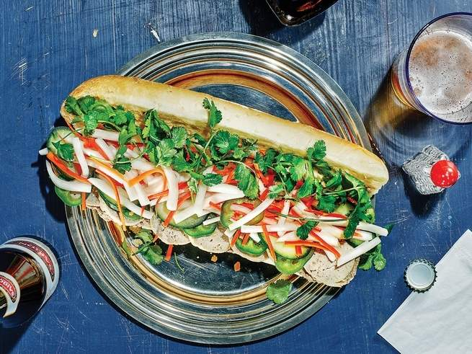

The pâté and cold-cut combo might be the best-known *banh mi*, but it's not your only option. [Get the recipe for Classic Sausage and Pâté Banh Mi](https://www.saveur.com/classic-sausage-and-pate-banh-mi-sandwiches-recipe)

People often act as if there is a holy grail of *banh mi* authenticity. But like a lot of Vietnamese dishes, these sandwiches are very casual and flexible, hard to mess up or interpret too loosely. You can stuff practically anything in one, which is more or less how they were invented: Good bread, butter, pâté, and Maggi Seasoning (a European umami-laden ­condiment) came to Vietnam with French colonists; porky fillings like *char siu* crossed the border from China; and local cooks ran with these new ingredients, adding their own vegetables and herbs to ­create something uniquely Vietnamese.

You might already know the classic *dac biet* (or “special”) banh mi, a sandwich that originated in Saigon and is sold by many street vendors today. It features pâté, cold cuts like the mortadella-style *gio lau* sausage or a chewy-­tender pork shank, mayonnaise, Maggi Seasoning, some pickled carrots and daikon, cucumber, chiles, and cilantro. It’s sensational, but it’s far from the only sandwich that can be called banh mi.

So, what can? I came up with a loose formula for my new book, [*Vietnamese Food Any Day*](https://www.amazon.com/Vietnamese-Food-Any-Day-Recipes-ebook/dp/B07CWGXVWB/ref=as_li_ss_tl?keywords=Vietnamese+Food+Any+Day&qid=1555335741&s=gateway&sr=8-1&linkCode=ll1&tag=saveur-20&linkId=b6819d514f60db171c40134f5b3edc92&language=en_US). With a combination of these five things, you’re on your way to a proper one.

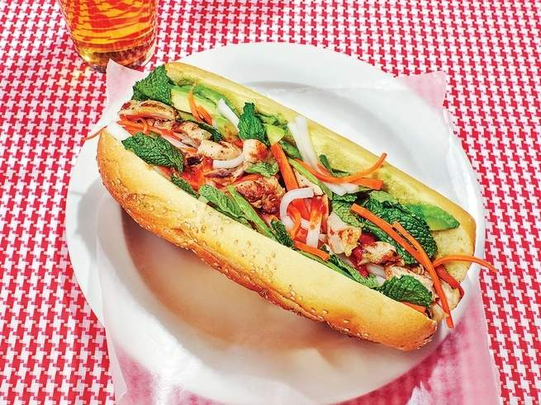

A riot of colors and flavors, this banh mi pairs juicy flame-kissed chicken thighs with creamy, cooling avocado. [Get the recipe for Grilled Chicken and Avocado Banh Mi »](https://www.saveur.com/grilled-chicken-and-avocado-banh-mi-sandwiches-recipe)

1. The Right Bread

Banh mi actually means "bread" in Vietnamese, and that was the case long before it ever referred to a particular type of sandwich. The sandwich is a casual street food, and the bread reflects this—the shape is usually similar to a small, single-serving baguette. Finding the right loaf when making one at home is both important and easy. The best bread will be light with a thin crust, a cottony interior, and a faintly sweet flavor—a combination of traits that today are often considered characteristic of lower-quality bread, but it's exactly what you want for your banh mi. Cut a section of a softer baguette or ciabatta, or you can even try kaiser rolls. But resist the temptation to use sourdough or a [crusty French bread](http://i.viglink.com/?key=b33c9a8db7a61caeec247e8778c24aa1&insertId=5e6c450f3a436112&type=H&exp=60%3ACI1C55A%3A20&libId=jv7yncvh01011mhe000DAjqjr97si&loc=https%3A%2F%2Fwww.saveur.com%2Fbest-banh-mi-formula%3Fsrc%3DSOC%26dom%3Dtw&v=1&iid=5e6c450f3a436112&out=https%3A%2F%2Fwww.amazon.com%2Fdp%2FB07PJLJ48S&ref=https%3A%2F%2Ft.co%2F4aMScxwIgm&title=Follow%20These%205%20Steps%20to%20the%20Best%20Banh%20Mi%20%7C%20SAVEUR&txt=%3Cspan%3Ecrusty%20%3C%2Fspan%3E%3Cspan%3EFrench%20%3C%2Fspan%3E%3Cspan%3Ebread%3C%2Fspan%3E) with a firm exterior and rustic chewiness. The flavor and texture will simply compete too much with the fillings. The bread is best when served warm and slightly crisp. It should be soft, but not too soft. Use a serrated knife to slit it open horizontally, maintaining a hinge on one side. Hollow out some of the inside to make room for the fillings.

2. A Smear of Fat

The cardinal banh mi sin is dryness. Vendors in Vietnam take inspiration from the French to avoid this: They will often generously spread mayonnaise or butter onto the two cut sides of the bread, covering the interior all the way to the edges. You can also use avocado, which is available in Vietnam, where it’s known as *trai bo* (butter fruit). Lay down thin slices of it, then mash them a little so they better adhere to the bread. “Banh mi are very casual and flexible, hard to mess up or interpret too loosely.”

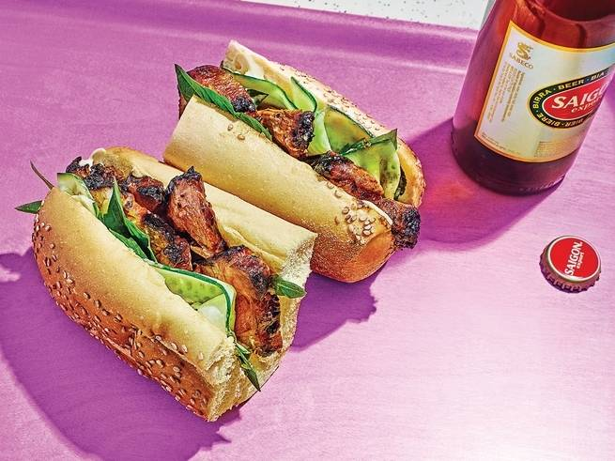

Thin strips of cucumber and hand-torn leaves of fresh basil are the perfect foils for smoky-sweet grilled pork in these hearty sandwiches. [Get the recipe for Chinese BBQ Pork Banh Mi »](https://www.saveur.com/chinese-bbq-pork-banh-mi-sandwiches-recipe)

3. A Dash of Seasoning

Maggi Seasoning sauce arrived in Vietnam with the French, and its deep, meaty flavor—landing somewhere between soy sauce and Worcestershire—has become integral to banh mi’s flavor. If it’s not available, a dash of [Bragg Liquid Aminos](https://www.amazon.com/Bragg-Natural-Liquid-Aminos-16oz/dp/B000QVDSUM/ref=as_li_ss_tl?keywords=Bragg+Liquid+Aminos&qid=1555354820&s=gateway&sr=8-4&linkCode=ll1&tag=saveur-20&linkId=02ce35c1e5653bbe324730edfc86badf&language=en_US) or soy sauce will get you close.

4. Protein

With the foundation set, the main filling will typically be one or two proteins. Pâté and Vietnamese cold cuts such as gio lau are classic. But grilled char sui is also wonderful and common, as is a two-egg omelet, well-seasond tofu, or even leftover roast chicken. Whatever you choose, don’t overstuff the bread: A balanced banh mi resembles a salad in a sandwich, with a 1-to-1 or 1-to-2 ratio of main filling to vegetables.

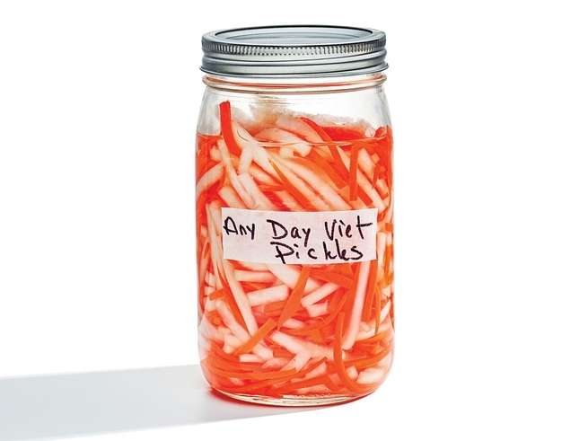

Nguyen calls these salty-sweet pickled vegetables "any day Viet pickles" because they're just that versatile. [Get the recipe for Vietnamese Daikon and Carrot Pickles (*Do Chua*) »](https://www.saveur.com/vietnamese-daikon-carrot-pickles-recipe)

5. Vegetables and Herbs

Something crisp, cool, and crunchy is vital in any banh mi. Tuck in any or all of the following: daikon and carrot pickles, fresh chile slices, thick strips of cucumber, or coarsely chopped or hand-torn fresh herbs. Cilantro may be most typical, but mint and basil are also great additions.

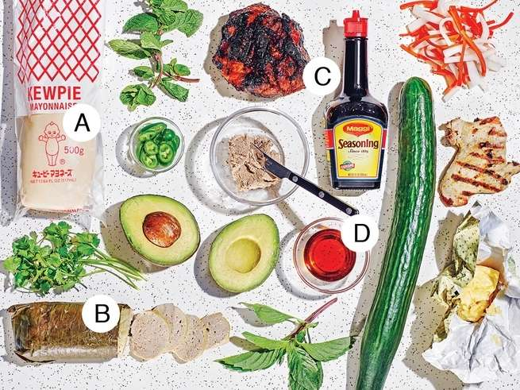

Just some of the many ingredients that can go into a banh mi. The Wide World of Banh Mi Ingredients

The banh mi is a uniquely Vietnamese combination of ingredients from around the world. Here are some of my essentials, from classic flavor foundations to nontraditional additions.

A. [Kewpie Mayo](https://www.amazon.com/Kewpie-Japanese-Mayonnaise-17-64-ounce/dp/B0128MOFY4/ref=as_li_ss_tl?keywords=Kewpie+Mayo&qid=1555354850&s=gateway&sr=8-3&linkCode=ll1&tag=saveur-20&linkId=5c89f7de11e2a5766b1d5a665925f6ec&language=en_US): This beloved Japanese brand, first made in 1925, tastes quite a bit different from a classic hand-whisked mayonnaise (or Hellmann’s, for that matter). It’s rich, with a rice-wine vinegar tang, and is flavored with spices and MSG. Don’t expect to find Japanese mayo being used by a Hanoi street vendor, but it tastes great, and including it does justice to the culturally omnivorous, everything-but-the-kitchen-sink spirit of these sandwiches.

B. *Chua Lua* Sausage: It is entirely ­possible to find factory-made versions of this Vietnamese cold cut in an Asian market, but you’d be surprised by how easy—and how much better tasting­—it is to make your own. This simple pork sausage is flavored with fish sauce and poached in a [banana leaf](http://i.viglink.com/?key=b33c9a8db7a61caeec247e8778c24aa1&insertId=a89465fceee308b6&type=S&exp=60%3ACI1C55A%3A20&libId=jv7yncvh01011mhe000DAjqjr97si&loc=https%3A%2F%2Fwww.saveur.com%2Fbest-banh-mi-formula%3Fsrc%3DSOC%26dom%3Dtw&v=1&iid=a89465fceee308b6&out=http%3A%2F%2Fwww.ebay.com%2Fsch%2F11700%2Fi.html%3F_nkw%3Dbanana%2Bleaf&ref=https%3A%2F%2Ft.co%2F4aMScxwIgm&title=Follow%20These%205%20Steps%20to%20the%20Best%20Banh%20Mi%20%7C%20SAVEUR&txt=%3Cspan%3Ebanana%20%3C%2Fspan%3E%3Cspan%3Eleaf%3C%2Fspan%3E) rather than a fussy natural casing. Folding it up is easy (no more difficult than making a burrito), and the wrapper gives the sausage a certain grassy flavor.

C. [Maggi Seasoning](https://www.amazon.com/Maggi-Seasoning/dp/B002UR987M/ref=as_li_ss_tl?keywords=Maggi+Seasoning&qid=1555354773&s=home-garden&sr=8-1&linkCode=ll1&tag=saveur-20&linkId=2572d8ce3c88226d1e5a70e94b91f3b3&language=en_US): Swiss inventor Julius Maggi was searching for a way to improve the nutrition and flavor of mass-produced meals for the new class of industrial worker when he invented the powerfully savory Maggi Seasoning sauce in 1886. It has since become a global brand that’s particularly popular in Asia and Latin America. Its exact formulation now varies around the world—some cooks will only use the version made for a certain country.

D. Fish Sauce: It’s hard to overstate the importance of this pungent condiment—­most typically made from fermented anchovies—in ­Vietnamese food. Some brands are more flavorful than others: Look for [Red Boat](https://www.amazon.com/Red-Boat-Kosher-Fish-Sauce/dp/B01BULR2HG/ref=as_li_ss_tl?keywords=Red+Boat+fish+sauce&qid=1555354922&s=gateway&sr=8-5&linkCode=ll1&tag=saveur-20&linkId=178f72a8907d0dcf87d59b43d5de5861&language=en_US) from Vietnam or [Thai Megachef](https://www.amazon.com/Megachef-Thai-Fish-Sauce-Premium/dp/B00D92SUQ2/ref=as_li_ss_tl?crid=1W5HBHT8RCCWV&keywords=megachef+thai+fish+sauce&qid=1555354951&s=gateway&sprefix=Thai+Megachef,aps,147&sr=8-3-fkmrnull&linkCode=ll1&tag=saveur-20&linkId=c228e52d6010da6572918187f9e646a6&language=en_US). It is used as a cooking ingredient in these recipes, but fish sauce is also used as a table condiment in Vietnam. It’s not exactly traditional, but a dash can add a jolt of salty, savory flavor to your banh mi.

**Recipe:** Chinese BBQ Pork Banh Mi Sandwiches. By [SAVEUR Editors](https://www.saveur.com/authors/saveur-editors) April 18, 2019

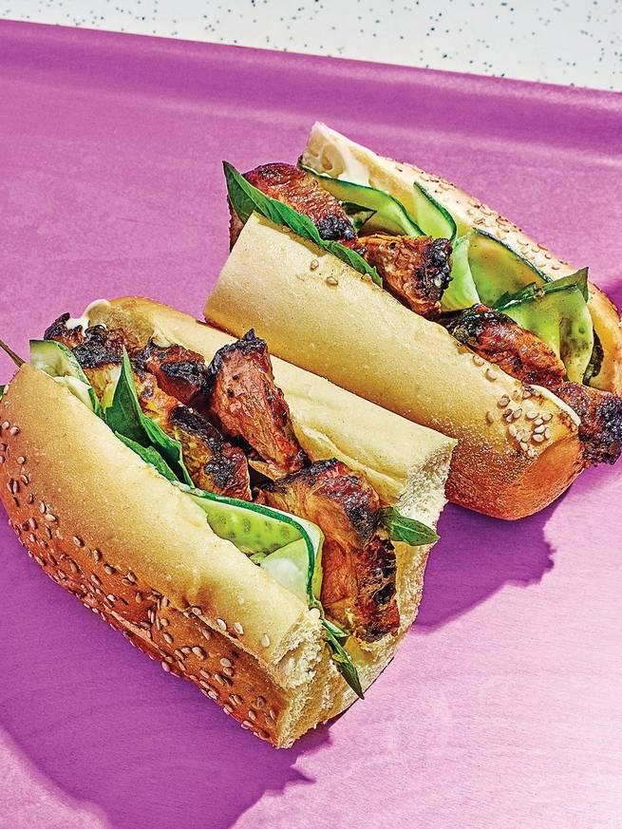

Thin strips of cucumber and hand-torn leaves of fresh basil are the perfect foils for smoky-sweet grilled pork in these hearty sandwiches.

Banh mi filled with Chinese-style barbecued pork (char siu in Cantonese, or thit xa xiu in Vietnamese) is a classic. Fiery sriracha mayo is available in Vietnamese stores, but you can mix your own or use Kewpie-brand mayo instead. Instead of pickled vegetables and cilantro, this sandwich uses fresh cucumber and aromatic basil. Makes 6 Sandwiches. 2 hours.

### **For the Pork**

2 medium garlic cloves, finely minced (1 tsp.)

½ tsp. Chinese five-spice powder

½ tsp. sugar

3 Tbsp. hoisin sauce

2 Tbsp. honey

2 Tbsp. ketchup

2 Tbsp. plus ½ tsp. soy sauce

2 tsp. toasted sesame oil

1½ lb. boneless pork shoulder, cut into strips approximately 2 inches thick and 6 inches long

Canola oil, for grilling

### **For the Sandwiches**

6 nine-inch hero rolls, split lengthwise, connected on one side like a hinge

1½ cups sriracha mayonnaise, or substitute Kewpie brand 1 Tbsp. Maggi Seasoning or soy sauce

1 English cucumber, peeled into ¼-inch strips or sliced into rounds (about 42 pieces)

1½ cups torn basil leaves

### **Instructions**

1. In a large bowl, add the garlic, five-spice powder, sugar, hoisin, honey, ketchup, soy sauce, and sesame oil, and stir well to dissolve the sugar. Set aside 3 tablespoons of the marinade, then add the pork to the bowl with the remaining marinade, tossing well to coat. Cover and set aside to marinate at room temperature for about 1 hour, turning the meat 2 or 3 times. For a deeper flavor, refrigerate up to 24 hours, then let rest at room temperature for 45 minutes before cooking.

2. About 45 minutes before you are ready to serve the sandwiches, grill the pork: Prepare a grill to medium heat or a grill pan to high heat. Add the pork and cook, turning frequently with tongs, until the meat is evenly seared on all sides, 18–20 minutes. Brush all over with the reserved marinade and continue cooking, turning as needed, until the pieces look glazed, are slightly charred all over, and have an internal temperature of at least 145°F, about 5 minutes more.

3. Transfer the pork to a platter and let rest for 10 minutes. Slice the meat against the grain into ⅓-inch-thick pieces.

4. Make the sandwiches: Spread the inside of one roll with ¼ cup of the mayonnaise and ½ teaspoon of Maggi Seasoning or soy sauce. Add ½ cup (3 oz.) of the sliced pork, followed by about 7 slices of cucumber and ¼ cup of torn basil leaves. ­Continue assembling the rest of the ­sandwiches in this manner, then serve.

**Recipe:** Vietnamese Daikon and Carrot Pickles (Do Chua)By [SAVEUR Editors](https://www.saveur.com/authors/saveur-editors) April 18, 2019 Cookbook author Andrea Nguyen calls these salty-sweet pickled carrots and daikon "any day Viet pickles" because they're just that versatile. Makes About 3 Cups.

A jar of *do chua* (“sour stuff”) adds color, crunch, and tang to banh mi. Daikon is classic but can be swapped out for purple turnips or slices of more-­colorful radishes. If the pickles turn stinky as they age, open the jar and let it air out for 15 minutes before using.

**Ingredients**

1 lb. fresh daikon, cut into 3x¼-inch strips (3⅓ cups)

2 medium carrots, peeled and cut into 3x⅛-inch strips (1½ cups)

1 tsp. fine sea salt

½ cup plus 2 tsp. sugar, divided

1¼ cups distilled white vinegar

**Instructions**

1. In a medium bowl, add the daikon and carrots; toss with the salt and 2 teaspoons of sugar. Set aside until you can bend a piece of daikon so the tips touch without ­breaking, about 20 minutes. Rinse the vegetables well with cold water, then drain, squeezing to expel any excess liquid. Transfer the vegetables to a quart jar.

2. In a medium bowl, stir the remaining ½ cup sugar with the vinegar and 1 cup of water until the sugar is dissolved. Pour enough of the liquid into the jar to completely cover the vegetables, discarding any excess. Set aside the jar at room temperature for 1 hour, then use the pickles immediately, or cover and refrigerate for up to 1 month.