Field Guide 3: Preparing Family Garden Beds and Planting Seeds.
By Tim Magee
Schedule a workshop with the community for eight hours. You can also do this workshop in two, four hour sessions.

How to teach community members to design a simple garden, dig beds and plant seeds in a workshop.
1. Introduction to nutrition and family gardens. For many people living in the cycle of poverty, the idea of starting a kitchen garden might seem overwhelming. It could be the time investment, it might be perceived costs. It might be a lack of know-how: what to plant, how to plant, and how to care for a garden. However, the positive benefits make it worthwhile enabling community members in gardening for nutrition.

Start small, think simple. The purpose of the first year's garden is to give the participants a win—so that they will be encouraged to plant again the following year. Even if they plant only one bed, 1 meter by 4 meters, they should be able to get positive, delicious, nutritious results.

2. Planning the garden. A garden must first be planned and designed. In the first year don’t get into too much detail; don’t scare people away from the idea with too much information. During the course of the year you can gradually teach them more so that they can do a better job of planning for year two.

Discuss planning for sun, exposure to wind, runoff, family size and food production, and crop choices for nutrition. Provide large sheets of paper for them to design an example garden. Ask participants to sketch the area around their house and begin thinking of a good location for their garden. Work with the family to make a decision: a single small bed the first year—or something bigger?

3. Discussing the importance of organic material. Discuss the importance of organic matter for the soil and the beds. In the first year, since they may not have compost, let them know that they can begin by spreading whatever chopped-up organic material (OM) they can find on top of the staked out bed location. This can be leaves, manure, corn stalks, vegetable-based kitchen scraps. Organic material in garden soil provides nutrients, structure and facilitates holding water. Explain how many freely available types of OM are available around the village for getting a garden plot started. Have participants discuss other materials that they might be able to use.

4. Raised garden beds. They provide a soft environment for roots, they drain well, and the soil flora and fauna receive the oxygen they need. Soil is a living, breathing organism of sand, clay, organic matter, earthworms, microorganisms, nutrients, minerals, water and plant roots. It can suffer from being too wet, too dry and too sandy. Organic material and the soft soil of the raised beds are a benefit for root penetration, drainage, aeration, nutrient availability, and structure.

5. Taking turns laying out and digging a bed, mixing in organic material and smoothing the bed. Stake out an area for a bed that is no wider than 1 meter; clear it of any vegetation or trash. Lay some organic material on top of the staked-out area. Beginning at one end of the new bed, dig a 1 meter long trench one shovel in depth and one shovel width wide. Place the soil to the side. With a garden fork or with the shovel, loosen the soil in the bottom of the trench a further shovel depth—but don’t remove it. Place some more organic material in the trench.

Dig a second trench alongside the first one, tossing the soil into the first trench. With the addition of the OM and the fluffing of the soil, the soil should now be higher than the surrounding terrain. Continue this process for the entire length of the bed. Place the reserved soil from the first trench into the last trench.

Using a garden rake, and without walking on the new bed, carefully break up any clumps of soil and rake the surface of the new bed smooth, flat and level. Carefully rake the outer edges so that they slope at a 45-degree angle, and so that a small lip forms at the upper edge for holding water.

6. Laying out a seed grid and planting a few example seeds at the right distances and depths. Nutritious plants should have already been selected and seeds obtained. The seeds should come with directions for correct spacing for planting and correct planting depths. Explain practical examples for seed spacing and planting depth: Crowding of plants, wasted space, and seed size versus planting depth. Explain how to measure out and mark the beds for planting the seeds. Being sure not to walk on the new beds. Help them plant a few seeds by demonstrating making a groove or a hole in the soil, planting and then covering the seed with soil. Show how to label the seed rows. Let the participants lay out the beds for the rest of the seeds.

7. Gently watering the newly planted seedbeds.
Use a watering can with a fine spray and gently water the newly planted seeds. Water slowly enough that the water can soak in and not form pools; pools can cause the seeds to float to the surface. Explain the best times of day to water, frequency, duration and quantity. Let the workshop participants take turns watering the newly planted seedbeds.

Put together a simple fence to protect the bed from animals. Be creative and use any free materials just to get going the first year. The fence could be made of branches, old tires, old barrels, or old pallets.
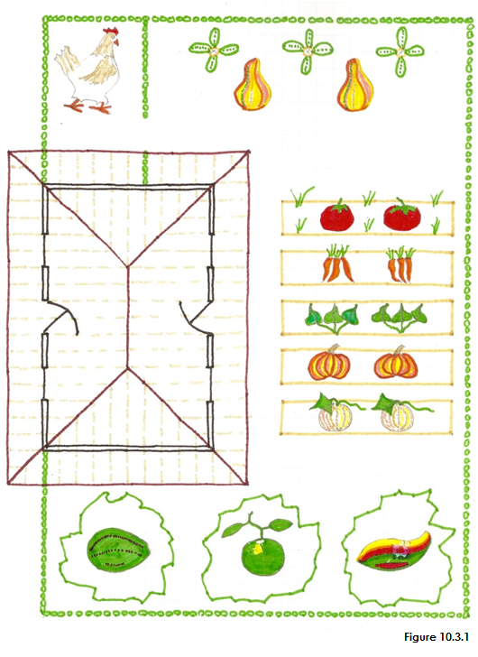 | 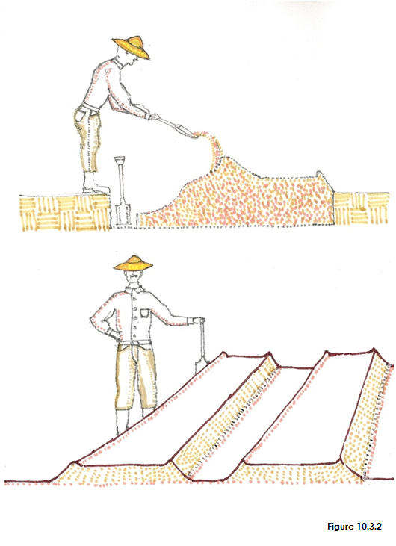
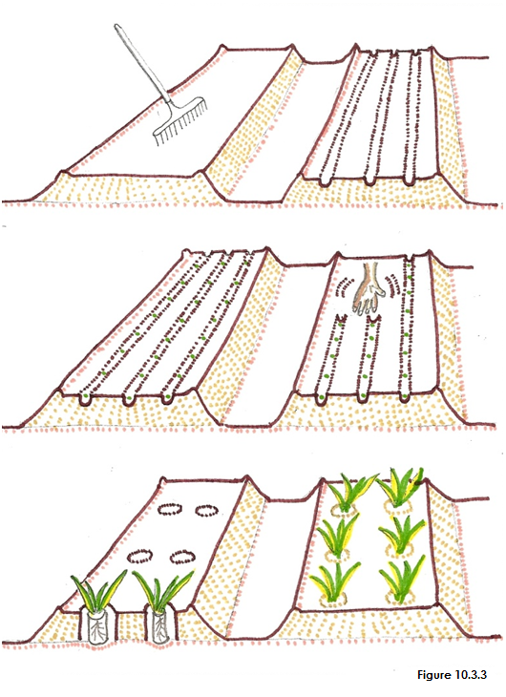 | 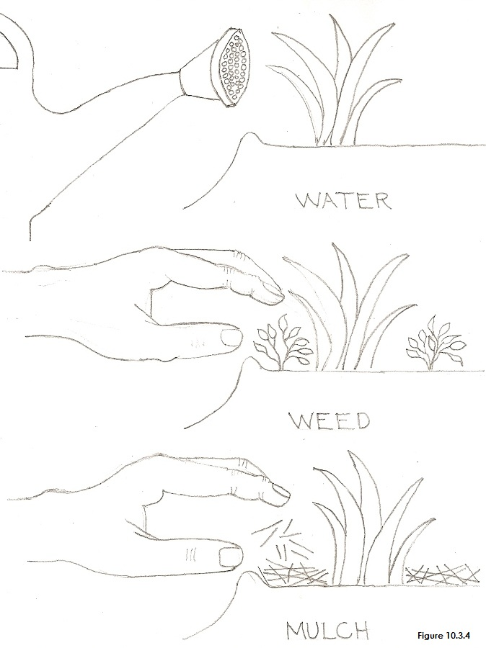
INSERT FIGURES 10.3.1, 10.3.2, 10.3.3, and 10.3.4, NEAR HERE

Field Guide 3: Workshop Lesson Plan for Preparing Family Garden Beds and Planting Seeds
8 hours including lunch (can be done in two, ½ day workshops)
PURPOSE: What workshop participants will be able to do as a result of the lesson.
Support participants in planting their first garden to improve food security and family nutrition.
Objective 1: All will know the proper method for preparing a raised bed that includes organic matter.
Objective 2: All participants will successfully be able to properly plant a variety of seeds.
Objective 3: All participants will understand why clearing and fencing the garden plot is important.

MATERIALS
- Artist’s drawings/posters; the scenes and people they contain should appear familiar to workshop participants.
- Variety of seed to be provided for participants by the project.
- Basic garden tools for instructor to use: Machete, Shovel, Rake, Trowel, Watering Can—a water source.
- Organic material (leaves, crop residue, manure) for mixing with soil.
- How-To Cards without written words for workshop participants to take home.
- Large sheets of newsprint and tape.
- Colored markers.

PREPARATION
- Find a workshop location. A participant’s, community center’s, school’s or church’s garden.
- Plan out the demonstration garden; this will be good preparation and practice for when you present this workshop.
- Clear the area of brush, weeds and trash in advance of the workshop.
- Prepare several beds in advance so there will be enough beds by the end of the day for planting seeds.
- Work with an agriculturist/nutritionist as necessary on background information and selection of nutritious plants.

BEGINNING OF LESSON:
Activity 1. 90 minutes (including a 15 minute ice-breaker). Garden Bed Introduction
Purpose: Introduce and explain what the value of a properly planned & prepared garden is in relation to family health.

What to do
- Ice Breaker: Introductions. Sing a song or play a game.
- Introduction to workshop: Tell the participants what they’ll be able to do as a result of the lesson
- Use practical examples of why they need to plan their garden:
- The need to plan for sun, exposure to wind, runoff, family size and food production, and crop choices for nutrition.
- Use large sheets of paper to design an example garden.
- Ask participants to sketch their yard and begin thinking of a good location for their garden.
- Summarize briefly:
- Examples of why the plot is cleared and fenced: residual contamination, weeds, insects, damage from animals.
- Examples of why they should loosen the soil and mix in organic material: Root penetration, drainage, aeration, nutrient availability, structure, micro ecosystem.
- Examples of seed spacing and planting depth: Crowding of plants, wasted space and seed size versus depth.
- Simple explanation of watering: Best times of day, frequency, duration and quantity.

Workshop Participants:
Take 5 minutes to talk about what you do and don’t understand, what you do and don’t like.

Activity 2. 30 minutes. Planning & clearing a small area of the plot and looking at a sample of fencing
This part of the lesson needs to be held outdoors in the example garden
Purpose: Show how the best spot was chosen for this garden and discuss fencing and what was cleared off the land.

What to do
- Discuss the location of the beds in relation to space, exposure, sun. What decisions were made?
- Ask for feedback from the participants.
- Show what was cleared off of the garden plot and re-emphasize why.
- Show a sample of the fencing that was used.

Workshop Participants:
Take 5 minutes to talk about what you do and don’t understand, what you do and don’t like.
BREAK: 15 minutes

Activity 3. 15 minutes. Looking at the organic material samples collected from around the village
Purpose: Explain how many freely available types of OM are available around the village for getting garden plot started.

What to do
- Discuss the different materials and where they were found.
- Have participants discuss other materials that they might be able to use.

Activity 4. 90 minutes. Taking turns laying out and digging a bed, mixing in organic material and smoothing the bed
Purpose: To practice the digging technique and the shaping of a raised bed.

What to do
- Show how to measure and stake out a bed—then let participants lay out two beds.
- Show how to double dig the bed and add in the OM—then let the participants take turns digging the bed.
- Show how the final shape of the bed can be formed and smoothed with a rake.

LUNCH: 30 minutes

Activity 5. 60 minutes. Laying out a seed grid and planting a few example seeds at the right distances and depths
Purpose: Re-emphasize seed spacing and planting depth.

What to do
- Show a chart with spacings for the different seeds and demonstrate how to transfer that to the planting bed.
- Let the participants finish laying out the beds for the different seeds.
- The chart gives seed planting depth; demonstrate making a groove or a hole in the soil, planting and then covering the seed.
- Show how to label the seed rows.

INDEPENDENT PRACTICE
Activity 6. 90 minutes. Planting the rest of the seeds and labeling the rows
Purpose: To let participants work through the entire process themselves—and to reinforce what has been learned.

What to do
- Let participants finish planting the seeds in the beds.
- Let them label the seed rows.

Workshop Participants:
Take 5 minutes to talk about what you do and don’t understand, what you do and don’t like.

Activity 7. 15 minutes. Gently watering the newly planted seedbeds
Purpose: To let participants work through the entire process themselves—and to reinforce what has been learned.

What to do
- Show the proper technique for watering the new seedbed.
- Let the workshop participants take turns watering the newly planted seedbeds.

Workshop Participants:
Take 5 minutes to talk about what you do and don’t understand, what you do and don’t like.

Activity 8. 30 minutes. Conclusion: Principles of plot & bed preparation, organic material, seed planting and watering
Purpose: To reinforce what has been learned and to discuss common mistakes and positive solutions.

What to do
1. Discuss and review what has been learned.
2. Discuss common mistakes and positive solutions observed during independent practice.
3. Reinforce the principles of garden planning and layout.
- Plan the garden for location, size, exposure and nutritional crops
- Layout, double dig and add OM to the beds
- Form with a rake
- Plant seeds to correct spacing and depth
- Water

Workshop Participant Feed Back:
Take 10 minutes to talk about what you do and don’t understand, what you do and don’t like.

HOMEWORK: Participants are to prepare a garden plan for their individual gardens for the first home visit by the field staff.

