Sutton, Bob OL-305 Assignment 1
Homework for Assignment 1. So your assignment for week one is to write me and tell me:
1. Where is a good space where you live (or near where you live) that you feel will work successfully for a small vegetable garden. Take a photo of the space with your cell phone and paste it into your homework.

Hi Tim. We have decided to pilot an elevated container garden suitable for seniors who have experience and who love to garden in the ground but whose mobility or space now limits in-ground gardening. Our pilot space is a level and sunny patio stone area, with a source of water nearby. The wind exposure is low but sun exposure is East-West with afternoon sun so we are thinking about possible heat stress and the need for shade. We plan to construct a flip-up work surface at one end to add to the utility and ease of use. Here are few photos:

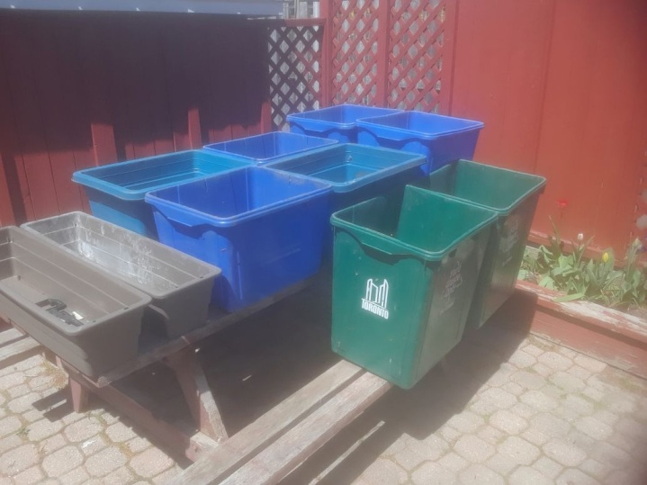 | 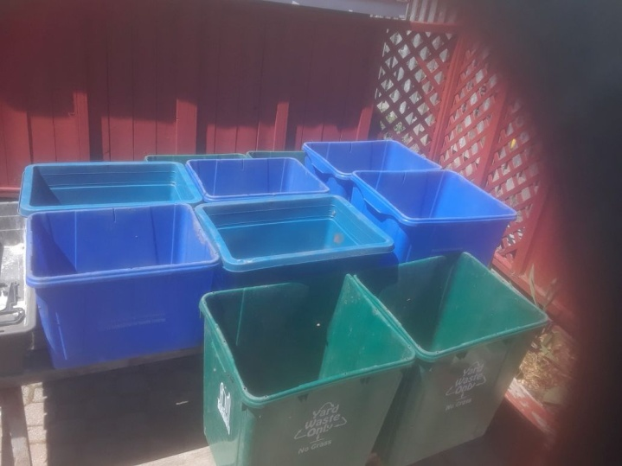
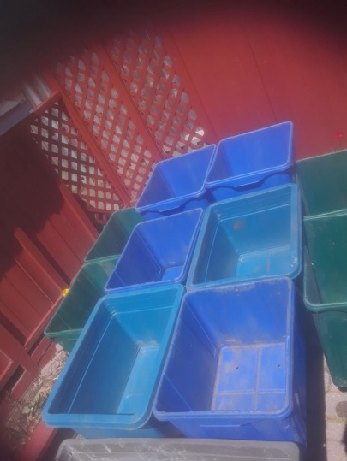

2. What are some ideas for containers that you've come up with. Are these things that you found where you live that will work temporarily to get started with? Did you decide to go out and buy some containers? Take a photo of the containers you like (or have) with your cell phone and paste it into your homework.

As you can see in the photos the homeowner had access to a collection of old recycling tub containers (varied sizes) that are no longer used by the city. The all have drainage holes and vary from 12 nches to 16 inches depth capacity. We decided to add the shallow & narrow planter boxes for shallow rooted veggies. These were purchased.

They will be secured to the picnic table after it is braced with a slender rail and all can be easily reached by the homeowner.

3. Nonprofit Professional Development:
Time to start your notebook! Print out this homework sheet and jot down a few things that maybe you had trouble doing and that you will need to remember when you begin teaching your constituents.

Great idea – We felt that this approach would work for many settings – where a yard was limited or for a balcony. Having containers to repurpose saved moeney and puts underutized plastic to a good re-purpose.

Thanks for the awesome set ot materials and links. So much to learn and apply.

